**National Health Center Training and Technical Assistance Partners (NTTAP) on Clinical Workforce Development**

**Communication Plan Template**

**Purpose: To keep stakeholders apprised of and engaged in your work, to control the narrative**

Whenever a new group in an organization begins meeting regularly, those outside—peers, managers, leaders—of the group start asking questions. *What are they up to? Why wasn’t I invited? What changes will the group make and how will those changes affect me?*  When you are in a position to introduce innovation in your organization, communication professionals will tell you this: *Control the narrative*. That means you need to drive the story of the work you are doing by being proactive; don’t leave it to others to guess. You need to 1) communicate on a regular basis with stakeholders in different parts of your organization, 2) make sure that your group implementing the innovation shares a consistent message, 3) and anticipate/address concerns, questions and challenges. By doing so, you will engage stakeholders in your work, have their support to get the resources you need to do the work, and have their support when it is time to execute change.

**Step 1: Do a stakeholder analysis**

Different stakeholders need different types of information about your work, and with different levels of detail. AS an innovator, you have to manage the relationships between your group and the stakeholders, and sometimes among the stakeholders. Think in terms of lateral and vertical relationships, that is, peers as well as those you report to and those who report to you: your boss, your staff, your peers, managers, leaders, other departments. Figure 1 analyzes stakeholders by the power they have to support innovation and their interest in your innovation. The higher their power and interest, the more closely you need to engage with those stakeholders.

*Figure 1. Stakeholder analysis: who do you need to communicate with and why*

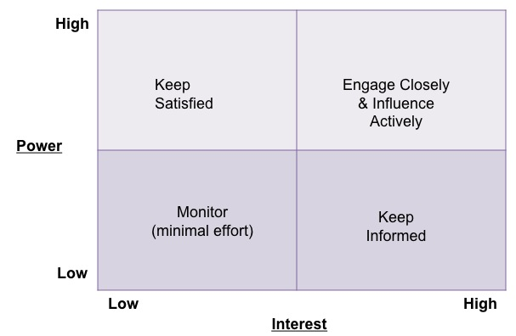

*Action step*: Create a grid like Figure 1 for your project, with names and roles of stakeholders (any big piece of paper will do). As you enter each name, ask yourselves these questions:

1. Why is this person a stakeholder?
2. What does this person know about your current project?
3. What is their opinion of your current project? Supportive? Opposed? Neutral?
4. What are the formal channels through which this person gets important information?

**Step 2. Who, what, when, where, why, how**

A communication plan is pretty straightforward as Table 1 below demonstrates. It lays out the who, what, when, where, why, how of engaging with stakeholders, and ensure that you are doing so. When you are communicating with someone who is above you in a leadership position, this is referred to as *managing up*. You have to manage their expectations for the work you are doing, but also manage the relationship between this person and the work group. Leaders move onto the next project and suddenly the resources you were promised are not available. You need to address that. Leaders want things to move more quickly, and are convinced they know the solutions. You need to explain how your group works and why. Finally, even leaders have a boss, and you don’t want your boss to be in the awkward position of not being able answer questions from his/her boss about your project.

*Action step*: Create your communication plan to engage your stakeholders! Just follow this example.

*Table 1. Example – Action Plan.*

|  |  |  |  |  |  |
| --- | --- | --- | --- | --- | --- |
| **COMMUNICATION PLAN – IMPORTANT PROJECT**  **DATE: November 2023**  **PROJECT LEAD: Mrs. Peacock** | | | | | |
| **Who: Stakeholder** | **Why communicate with this person?** | **What: Message(s) for this person** | **Who: Who in your project group will communicate with this person?** | **When and how often?** | **How: What venues or media will be used?** |
| Mr. Green, CEO | Has invested in time for us to meet.  Will need his/her support to implement the innovation. | Assure him/her that we are using time well.  Update on progress of group, lessons learned from other groups, ideas for implementation and application.  Keep good energy.  Don’t: tattle or report on internal group dynamics, keep that amongst the group. | Colonel Mustard, Director of Big Department and Project Lead | Monthly meeting of directors.  One-on-one meetings as appropriate to request resources as needed or ask advice. | Oral report monthly but written report added to meeting minutes. |

*Table 2. Blank*

|  |  |  |  |  |  |
| --- | --- | --- | --- | --- | --- |
| **COMMUNICATION PLAN – [PROJECT NAME]**  **DATE:**  **PROJECT LEAD:** | | | | | |
| **Who: Stakeholder** | **Why communicate with this person?** | **What: Message(s) for this person** | **Who: Who in your project group will communicate with this person?** | **When and how often?** | **How: What venues or media will be used?** |
|  |  |  |  |  |  |