* Have you ever had any type of sex ?
  + Oral, Vaginal, Anal?
* When was the last time?
* Are partners men, women, transmen, transwomen? How many (1 or more than 1)?
* Do you use condoms/on PrEP? Always, sometimes, never?
* Any symptoms?
* Were you exposed to any STDs that you know?

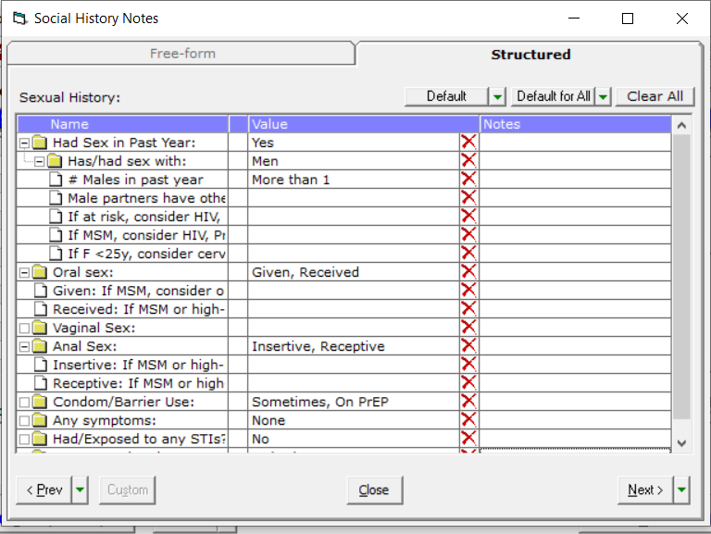

Jeannie:

My MA mentioned to me that you had some questions about you sexual health. I am glad you brought this up. This is something I do like to ask of all my patients to help me better take care of you. Is it OK if I ask you some questions about your sexual health?

Patient (MSM):

Yes, thank you, I would like that.

Jeannie:

That’s great. Thank you. Have you been sexually active in the past year?

Patient:

Yes, I have.

Jeannie:

When was the last time you were sexually active?

Patient:

Yesterday.

Jeannie:

OK. Have you had one partner or more than one partner in the past year?

Patient:

I have had a few partners.

Jeannie:

Are you partners male, female, both? Trans?

Patient:

Male only

Jeannie:

When you are sexually active with your partners, what kind of sex are you having? Oral sex? Anal sex?

Patient:

What do you mean oral?

Jeannie:

For oral sex, would mean there is contact between you and your partners’ mouth and penis. I am going to use a regular word that people use and I apologize if it is offensive—but I want to make sure you understand—I am referring to “blowjob”.

Patient:

Oh yes, I do both.

Jeannie:

Do you have oral sex both ways—you give your partner and they give to you?

Patient:

Yes

Jeannie:

How about anal sex, both ways as well? Top and bottom?

Patient:

Yes

Jeannie:

Do you us condoms for oral sex?

Patient:

No

Jeannie:

How about anal sex?

Patient:

Not always.

Jeannie:

Have you every had a sexually transmitted infection?

Patient:

Ever? Yes, I had gonorrhea a few years ago.

Jeannie:

Was the gonorrhea in your penis?

Patient:

Yes.

Jeannie:

Do you know if any of your current partners have had STIs?

Patient:

No

Jeannie:

DO you have any symptoms right now? Any burning or discharge from penis? Anal pain? Or Sore throat? Any new lumps or bumps?

Patient:

No, nothing right now.

Jeannie:

IS there anything else you want me to know that I did not ask about?

Patient:

Not really.

Jeannie:

Do you know about PrEP, are you on PrEP?

Patient:

I know about it but I am not on it. I do have some friends who have told me I should go on it.

Jeannie:

That is great. I think you would be a great candidate for PrEP which will help prevent you from getting HIV given that you have several partners over time and that you are not always using condoms, PrEP will help protect you against HIV. It will not help against other STIs but will against HIV. Condoms will help against other STIs as well. Would you like to learn about PrEP or would you like PrEP.

Patient:

I would actually like to go on PrEP.

Jeannie:

I think that is great. Why don’t we do STI and HIV testing today then since we need an HIV test before we prescribe PrEP. I would like to swab your throat and anal area for GC/chlamydia and we will do urine for GC and chlamydia as well to make sure you don’t have either in your penis. I will also want to do a blood test for syphilis if that is OK. We can do a rapid test today for HIV if you have time—or we can do the blood draw for it as well.

Patient:

That is great. OK. Let’s do it.