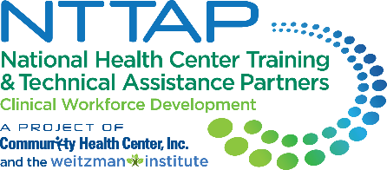

**NTTAP Postgraduate Nurse Practitioner (NP) Residency and**

**NP/Physician Associate (PA) Training Programs Learning Collaborative**

**Storyboard Content Collection Tool**

The NTTAP team wants to help each health center tell the story of your involvement in the Postgraduate Nurse Practitioner Residency and Fellowship Program Learning Collaborative through a storyboard. This storyboard process will allow each health center to compile the work you have done in this learning collaborative in a simple snapshot for you to share with other team members, leadership, and partners to help you continue to implement a postgraduate nurse practitioner residency program at your health center.

**Storyboard Purpose**

* Tell the story of your health center’s work during this learning collaborative in a clean, crisp, visual format
* Generate reflection among you and the other team members about your involvement in this learning collaborative
* Share your work in future meetings with other health center staff including leadership and external stakeholders such as the health center board, community partners, and funders

**Process**

* Complete the “Response” column in the table below following the prompts in the “Storyboard Section” column.
* Send your completed template to Meaghan Angers at [angersm@mwhs1.com](mailto:angersm@mwhs1.com) by Monday March 18th
* The NTTAP Team will edit and design the storyboard using the content you provide.
* The NTTAP Team will send your draft storyboard via PDF by Wednesday March 27th
* Be prepared to share the showcase in the last learning session on Tuesday April 2nd at 1pm ET / 10am PT

**Storyboard Content Guidelines**

* Complete all the required sections (*) and complete as many other sections as possible
* Use bullets and begin with action verbs like “developed” and “established.”
* Adhere to word count requirements.
* View the storyboards at the end of this document for examples of how your information will be shaped into a storyboard.

**Storyboard Content Collection Tool**

Due: Monday March 18th

Email to Meaghan Angers at [angersm@mwhs1.com](mailto:angersm@mwhs1.com)

**\* = required sections**

|  |  |
| --- | --- |
| **Storyboard Section** | **Response** |
| **\*Health Center Name and logo**   * *Type your health center name in the response box* * *Send image to Meaghan Angers at angersm@mwhs1.com (Do not embed logo in a Word document)* |  |
| **\*Health Center Description**   * *Provide a brief description of your health center* * *60 words MAX* |  |
| **\*Innovations**   * *List 3-5 changes that demonstrate your health center’s movement toward implementing a postgraduate residency program.* * *90 words MAX* |  |
| **\* ‘Aha’ Moment(s)**   * *A “lightbulb” moment during this learning collaborative* * *70 words MAX* |  |
| **\*Recommendation(s) to others**   * *Provide up to 3 recommendations for others starting to implement a postgraduate NP residency program or in the learning collaborative* * *60 words MAX* |  |
| **Aim Statement /**  **Mission and Vision Statement**   * *Add your most up-to-date mission and vision for your postgraduate NP residency program.* |  |
| **Program Drivers**   * *Add your most up-to-date program drivers for your postgraduate NP residency program.* |  |

|  |  |
| --- | --- |
| **Core Program Elements**   * *Add your most up-to-date core program elements for your postgraduate NP residency program.* |  |
| **Measures/Impact**   * *Looking at your data or Baseline Assessment, identify the most significant data point that highlights the importance of your work. You may use the results from the ORIC or RTAT self-assessment, which are available via Moodle.* |  |
| **Key Partners**  *Stakeholders related to the goals of this project:*   * *Internal: within the health center- (leadership, patient advisory groups)* * *External: outside of the health center (community organizations; schools; universities)* * *Do not include names – just titles and/or organizations* |  |
| **Voice of the Team**  *Provide a brief statement from one of the team members about the impact of your project work*   * *List name of team member and job title* |  |
| **Voice of Leadership**  *Provide a brief statement from a health center leader on the impact of your project work on the health center organization*   * *List name of leader and job title* * *Could use a quote from the application/letter of intent submitted for this learning community* |  |
| **Process Map or other Visuals**   * *Visuals such as photos, graphs, or updated workflows/process maps* * *Send image to Meaghan Angers at angersm@mwhs1.com (Do not embed in a Word document)images embedded in a Word document* |  |
| **Other**  *Include any assignment you completed during the Collaborative that was a success to implement your postgraduate NP residency program.* |  |

* Required

**Example Storyboard Template**

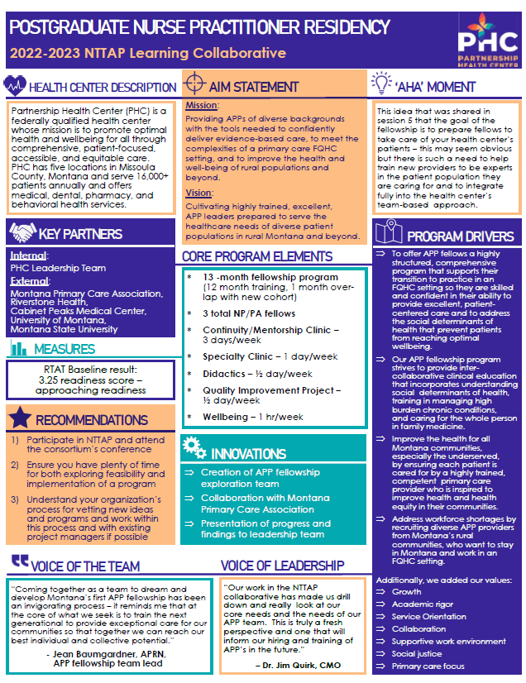

**Example Storyboard Template**

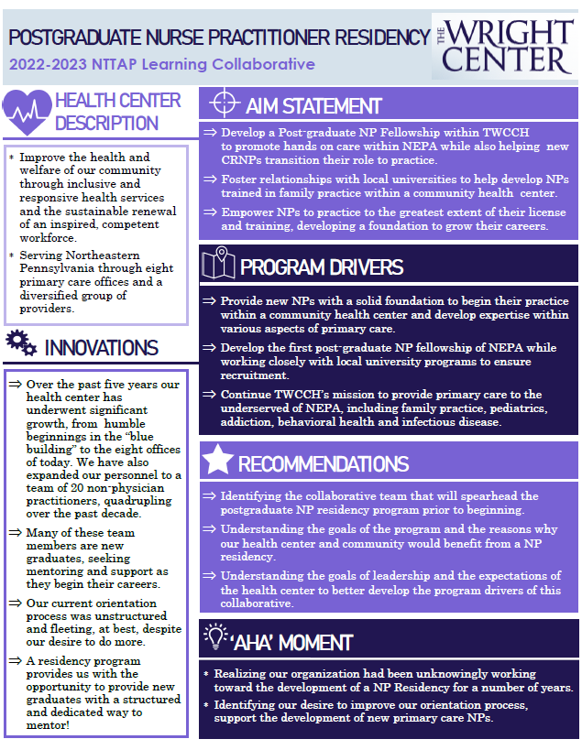

**Example Storyboard Template**

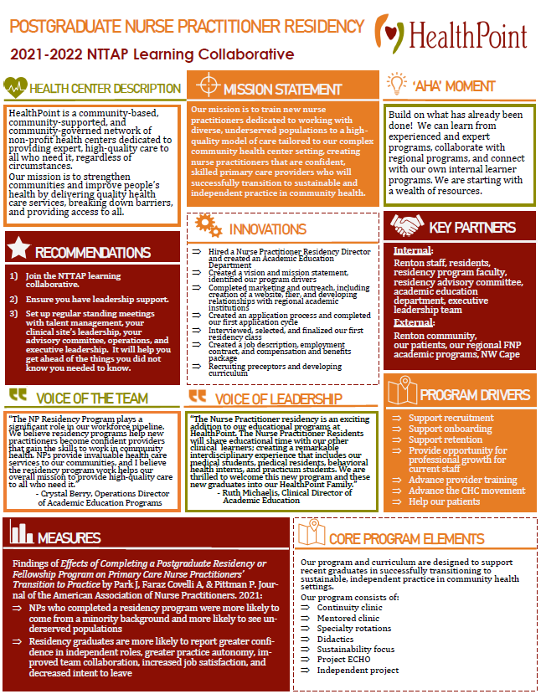

**Example Storyboard Template**

