NTTAP Team-Based Care Learning Collaborative: QI Workbook 2021-2022

This workbook is designed to accompany our quality improvement (QI) series for the Team-Based Care Learning Collaborative. In our experience working with teams from around the country, we found that many struggled with data as they developed their global and specific aim statements, and as they measured change during Plan-Do-Study-Act-cycles. The data often came from reports pulled from electronic health records by information technology and/or business intelligence personnel. Some organizations have internal staff in these departments while others outsource data management to vendors. Most often, data is used to report QI indicators, such as Universal Data Set (UDS) or National Committee for Quality Assurance (NCQA) measures. Frontline teams may or may not see these reports, and when they do, have no context for what they mean. In our collaboratives, we ask teams to measure changes in their practice, and thus it is important to become familiar with how data is defined, collected, and used.

This workbook covers:
- Types of data
- Define your data and how it is categorized
- Global aim (which does not use data)
- Specific aim (which uses specific data)
- Data collection
- Data display

PART I: WHAT KIND OF DATA DO YOU HAVE?

There are many kinds of data, and the type of data you have determines how you can use it to measure performance. Let’s review the types of data. The most basic types of data are qualitative and quantitative, as explained in Table 1 below. You will probably be using quantitative data most of the time, that is, numbers.

Table 1. Qualitative v quantitative data

Qualitative data | Quantitative data
- Usually words  - Pros: rich contextual descriptions of the topic  - Pros: Can be turned into quantitative data using scales  - Cons: bias in interpretation, lack focus  - Cons: Harder to do than you think | - Numbers  - Pros: universal language  - Pros: focus on key issues and outcomes  - Cons: can be difficult to obtain and interpret  - Cons: lack context, reductionist

Types of numbers: Ratio and Interval

Most of your data, such as UDS measures, is ratio data in which you count numbers of patients, events (no-show rates), objects (syringes), and so on. Ratio data have a natural zero, that is, you can have “zero” patients. Sometimes ratio data is called continuous data or parametric data because it can be added, subtracted, multiplied and divided. Ratio data is used for counting and measuring (Table 2).

Table 2. Ratio quantitative data

Definition and uses | Ratio data are raw numbers with a natural zero.
Why it matters | Can be added, subtracted, multiplied and divided. This is important for some statistical tests and run charts.
Example | You can have “zero” patients screened.  10 patients screened is two times 5 patients screened.
Counting v measuring | When counting, you use whole numbers: you can’t count ½ a patient.  When measuring, you can have fractions: ½ cup.  Technically, time is measured, not counted. You can have 1 ½ minutes which is half of 3 minutes. But because time is not measured in base 10 (there are not 100 minutes in an hour), calculations in excel, run charts or other statistical tests require different formulas than most ratio data. This is important if you are studying cycle time, for example.

Interval data (Table 3) are also a type of parametric data because the data points are equidistant. For example, there are ten degrees of temperature between 60° F and 70° F, and ten degrees between 70° F and 80° F. But there is no natural zero in interval data: they can be added and subtracted but not multiplied and divided. Temperature is the most common example.

Table 3. Interval quantitative data

Definition and uses | Interval data are raw numbers without a natural zero, but there is equal distance between any two data points.
Why it matters | Can be added and subtracted but not multiplied and divided. This is important for some statistical tests and run charts.
Example | You cannot have “no temperature.”  90° F is 45° degrees more than 45° F, but you cannot say that 90° F is two times hotter than 45° F.
Challenges | Easy to confuse with ratio data.

Other data types
Other types of data are nonparametric. Nominal data are categories to which someone belongs, but you are not usually interested in counting how many are in those categories. They are attributes of a research subject, such as gender or age group. Ordinal data involves ranking something first, second, third, and so on. The distance between each rank is not relevant, just the order of ranking. Nonparametric data cannot be added and subtracted, multiplied or divided. They are subjected to nonparametric statistical analysis instead. Most of your data will not be of this kind but it’s important to know the difference.

- Key point: The type of data determines the type of analysis you can do.

Types of practice data

In order to improve patient and quality outcomes, you need to change the structure (e.g., team composition, templates in the EMR) and care delivery processes (workflows) of your day to day practice. The graphic from Donabedian below illustrates the concept of structure-process-outcomes. Many people become impatient with process, but without process, there are no outcomes.

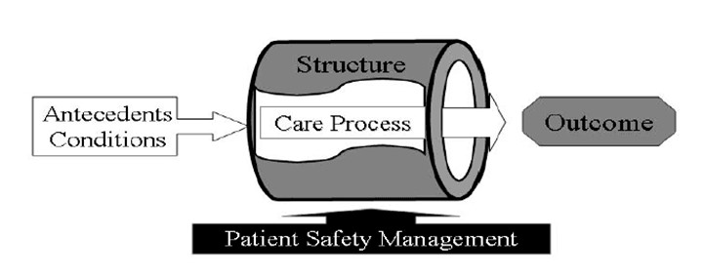

Structure:
- Physical and organizational characteristics of where health care occurs
- Capacity and systems in place to provide care
- Examples: Space, staffing ratios, Panel Size, Pods, core teams, EMR
- Some sources for you: Practice Assessment Guide

Process measures:
- How care is delivered to patients
- What happens to ensure care is delivered, what staff do
- Examples: screening rate, cycle time, no show rates
- Sources: Role Activity Analysis

Outcome measures:
- Effects/ results of health care delivery on the status of patients and patient populations
- Examples: percent of population with diabetes under control, patient satisfaction
- Sources: UDS measures

Part II: Define your data

Here are some common types of data that our teams work with:

- No show data: What is our no show rate?
- Screening data: What is our screening rate for cervical cancer?
- Chronic disease measures: What percent of our patients with hypertension are in good control?

All of these questions represent quantitative data, that is, numbers. But the larger data set (population) is further broken down into two or more mutually exclusive subsets, i.e., groups or categories, using pre-determined attributes, such as time, place, age, gender, diagnosis, and so on (Table 4). One data point [e.g., one person/object/event] belongs to the larger data set, but to only one subset. That is, one data point can’t be counted twice. For example, a patient either showed up for a visit or did not show up, screening was done or not done, a syringe was used or not used. A patient is either married, divorced, widowed or unmarried, but not all four at the same time.

Define your data: subsets, populations

Table 4 is an example of defining your population and subset(s). It includes time frame, source of evidence for your data, numerators and denominators. As most of your data comes from the EMR, include documentation in your definition, because it is evidence that a patient was seen/not seen, screened/not screened, and so on.

Table 4. What’s our no show rate?

Definition | A no-show is a patient who did not show up for a scheduled visit within a specific time frame and thus was not seen. Patients who call to cancel are not “no-shows.” Patients who are late but are eventually seen are not “no-shows.”
Time frame | July 2019
Population and subsets | -- Population A+B: all patients who had an appointment in July 2019 whether they attended the appointment or not (N=100)  --Subset A: patients who had an appointment in July 2019 and attended appointment as documented (N=80)  --Subset B: patients who had an appointment in July 2019 and did NOT attend the appointment as documented (N=20)
Source of data/evidence | As documented in the EMR
Numerators and denominators | No show rate = Subset B / Population A+B = 20/100 or 20% in July  --Numerator: Subset B  --Denominator: Population A+B
Challenges | Check to be sure that your (EMR) collects the data in a way that is consistent with the definition you are using to sort your patients into groups. What is the definition of “patients who had an appointment in July 2019 and missed the appointment?” What if someone showed up late but was still seen?

- Key Point: Define your population and subsets.

- Key point: Numerators are your sample/subset of the population that is your Denominator.

- Key point: Define the source of evidence for your data.

The definition of “no show” may vary by organization. For UDS measures, such as screening and management of chronic conditions, the definition of the population of interest and subsets are pre-determined by the national organizations to which the data is submitted. Defining the denominator is often the most difficult part of determining percentages and rates because it means clarifying who your population is. For example, defining who and who is not a patient is critical, e.g., is “a patient” an individual who has been seen at your clinic for any reason within the past 12 months?

- Key point: If you can’t define it, you can’t measure it.

Worksheet: Data and defining your groups

Exercise One. What is our screening rate for cervical cancer in the first quarter of 2021?
Definition of cervical cancer screening rate per UDS
Time frame | January, February, March 2021
Population and subsets | Population of patients eligible for screening:  Screened:  Not Screened:
Source of data/evidence
Numerators and denominators | Numerator:  Denominator:
Challenges

Exercise Two. What percent of our patients with hypertension were in good control in the first quarter of 2021?

Definition of hypertension in control per UDS
Time frame | January, February, March 2021
Population and subsets | Population of patients:  Controlled:  Not controlled:
Source of data/evidence
Numerators and denominators | Numerator:  Denominator:
Challenges

PART III: WHAT DO YOU WANT TO IMPROVE AND WHY: GLOBAL AIM

The Global Aim is broad, is based on a general problem or area for improvement that you have identified and what that improvement would look like, but have not yet determined what strategies you will take to make that improvement or how you will measure success. It describes what you aim to improve and where and why, but it does not go into how or by how much.

Global Aim Statement

Theme for improvement: Choose a clinical issue that needs improvement based on your practice assessment. “Communication” and “team morale” are not global aims. By choosing a clinical issue to work on, you will improve communication and team morale as a result.
- Example: improve UDS measure for Cervical Cancer Screening

We aim to improve (what): Choose a clinical process with a beginning, a middle, and an end over which you have some control because you will be designing PDSAs to improve it. Common ones include UDS and other reportable measures, cycle time, no-show rates, and closing the loop on referrals or med refills. Each of these has a process.
- Example: We aim to improve the cervical cancer screening process…

- Key point: Choose a clinical process with a beginning, a middle, and an end over which you have some control.

- Key point: A Global Aim statement does not have numbers or percentages nor strategies for improvement.

In (where): Identify the specific clinical site or team where you will work on improving the process.
- Example: at the Main St. Clinic, Dr. Smith’s panel of patients or Pod A.

The process begins with/when (what): You will be mapping out the process so identify the beginning and end, the bookends of the process. The process is something that you do, it is observable and hands on; it is not the outcome. The process starts when someone does something. Typically, improving screening data begins with identifying the patients who are due for/eligible for screening. Cycle time may begin when the patient arrives to check in. Of course, you have no control over when a patient arrives. But you do control when the MA rooms the patient.
- Example: The process begins during pre-visit planning by identifying the patients who are due for/eligible for screening based on UDS definition of eligibility.

The process ends with/when (what): The process starts when someone does something, and it ends when someone does something. If you are improving UDS or other reportable measures, that data is based on what is in the chart, so the process ends when someone documents the results in the chart. For cycle time or closing the loop on med refills, choose an end point that you have control over and that gives you actionable data. For cycle time, do your patients check out? Or do you rely on the MA or provider to close the chart? Defining the end point is critical. For med refills, ending with “the patient picks up the medication” is not something you can control, and is a different problem. But you can end with documentation that the med refill request was completed, which will have a time stamp.
- Example: The process ends with documentation in the EMR that screening has been completed.

- Key point: The process is something that you do, it is observable and hands on; it is not the outcome.

- If you can’t define where a process begins and ends, you can’t measure it and if you can’t measure it, you can’t improve it.

- Key point: When measuring performance, such as UDS measures, the clinical care process usually ends with documentation in the chart because that is what the measure is based on.

By working on the process, we expect (why): What do you to happen as a result of working on improving this clinical process? This is your rallying cry to your team. We will improve UDS measures! We will streamline and standardize a process! We will clarify who does what when! We will save time and money!
- Example: By working on this, we expect to improve our UDS measure for cervical cancer screening, clarify the process for how documentation of screening by providers outside of our clinic gets into the EMR, and reduce gaps in care.

Global Aim template
Theme for improvement: ____________________________________________________________
(Based on your practice assessment)
We aim to improve: _________________________________________________________________
(Name the process)
In: _______________________________________________________________________________
(Clinical location in which process is embedded)
The process begins with: _____________________________________________________________
(Name where the process begins)
The process ends with: _______________________________________________________________
(Name the ending point of the process)
By working on the process, we expect: __________________________________________________

It’s important to work on this now because: __________________________________________________

Example of a Global Aim: We aim to improve the rate of cervical cancer screening for Dr. Smith’s panel in Pod A at the Main St. Clinic. The process begins during pre-visit planning by identifying the patients who are due for/eligible for screening based on UDS definition of eligibility. The process ends with documentation in the EMR that screening has been completed. By working on this, we expect to improve our UDS measure for cervical cancer screening, clarify the process for how documentation of screening by providers outside of our clinic gets into the EMR, and reduce gaps in care. It’s important to work on this now because our screening rate has declined, and we have new staff we can train to a new workflow.

Worksheet: Write a global aim

Common mistakes:
- The theme is too broad and/or is not based on an assessment of your practice, e.g., “communication”
- The global aim will be difficult to measure, e.g., “improve the efficiency of …..”
- The global aim includes a strategy, e.g., “we will improve the UDS measure by doing [this or that].” Save strategies for the PDSA.
- The location—which will identify the team and/or population of patients—is not clear
- The process does not have a clear beginning, that is, what does someone do to get the process started?
- The end of the process gets mixed up with the outcome measure. For example, the end is not “increased screening rate,” the end is that someone “documented in the record.”
- Expectations are too high!

Global Aim template
Theme for improvement: ____________________________________________________________
(Based on your practice assessment)

We aim to improve: _________________________________________________________________
(Name the process)

In: _______________________________________________________________________________
(Clinical location in which process is embedded)

The process begins with: _____________________________________________________________
(Name where the process begins)

The process ends with: _______________________________________________________________
(Name the ending point of the process)

By working on the process, we expect: __________________________________________________

It’s important to work on this now because: __________________________________________________

PART IV: HOW WILL YOU KNOW IF YOU IMPROVE IT: SPECIFIC AIMS

The Specific Aim is narrow, uses measurable targeted goals (numbers, percentages, rates), and is the basis for PDSAs. One Global Aim can have several Specific Aims, and one Specific Aim can have many PDSAs.

A good specific aim states: What you will accomplish and how you will know it when you do. Or don’t.
- A good aim is based on baseline data.
- A good aim has measures that are clearly defined:
  - What is being measured
  - How it will be measured (numbers, percentages, rates)
  - When it will be measured
- A good aim measures something that matters.
- A good aim is achievable. That is, you can get the data and change the process that results in the data.
- A good aim is the foundation for PDSA(s).

- Key point: A measurable specific aim is the foundation for PDSA(s).

Specific Aim

We aim to: An improvement should be measurable—either you want to increase a rate or percentage (cervical cancer screening) or you want to decrease a rate or percentage (no-shows).
- Example: We aim to increase the percentage of documented cervical cancer screenings…

By: How much of an improvement are you aiming for? A percentage increase by itself is weak and not measurable. It works best if you have a baseline and target than just a percentage increase (more on that later).
- Example: by 15% (weak)
- Example: from 22% to 25.3% (specifically what a 15% increase is)

By: When will you measure your outcome? You need enough time to do some PDSAs and give them a chance to work. Have a beginning (baseline data) and ending date (target). Targets are usually measured in weeks, months, or quarters.
- Example: from January 1 through February 28.

Specific Aim Template

We aim to: __improve __decrease __increase

The _____number/amount ______rate/percentage of _______________
[process/measure]

By: ____percentage AND/OR From: _____________________ To: ___________________
[baseline number/percent] [target number/percent]

By/Between: Date _________________________

Example of weak specific aim: We aim to increase screening rate for cervical cancer in women patients by 15% from January to February.

Better: We aim to increase screening rate for cervical cancer in female patients ages 23 to 64 by from 22% as of January 1 to 25.3% by February 28.

Percent versus percentage points in specific aims

People often use percent and percentage increases and decreases interchangeably but they are different (Table 5). You will find that using percentage points is cleaner. In Table 5 below, if the baseline is 22%, then a 15% increase is 25.3%. But an increase in 15 percentage points is an increase from 22% to 37%. That is a big difference in the numbers of patients you will need to screen to reach your target! Examples for increasing and decreasing rates are below using percents v percentages are below (Tables 6 and 7). Having trouble remembering middle school math? See Tables 8 and 9!

Table 5. Percent v percentage points

Percent | Baseline screening rate: 22%  We aim to increase screening rate for cervical cancer in eligible female patients by 15% from January to February (15% more than 22% is 25.3%).
Percentage points | Baseline screening rate: 22%  We aim to increase screening rate for cervical cancer in eligible female patients by 15 percentage points from 22% from January as of January 1 to 37% by February 28.

- Key point: Percentage points are cleaner and easier to work with.

Table 6. Increase screening rate: percent v percentage points
Month | # eligible patients: A+B | # screened eligible patients: A | 15% Percent increase | 15 Percentage points increase
January 1 Baseline | 150 | 33 | Baseline 22% | Baseline 22%
February 28 Target | 150† | Target ??? | 22% * 1.15 =Target 25.3% | 22% + 15 points = Target 37%
How many more patients need to be screened in February? |  |  | Target 38 patients which is 5 more patients | Target 56 patients, which is 23 more patients

†Challenge: Obviously the January 1 baseline is based on December 31. What will you use for your denominator if you don’t yet know how many eligible patients will actually keep their appointments? You can use the denominator from the previous month, or estimate it based on an average of previous time periods.

- Key point: Estimate the denominator for your targets based on previous periods of data collection.

Table 7. Decrease no-show rate: percent v percentage points
Month | # patients with scheduled appointments: A+B | # no-show patients: A | 15% Percent decrease | 15 Percentage points decrease
January 31 Baseline | 150 | 33 | Baseline 22% | Baseline 22%
February Target | 150† | Target ??? | 22% * 0.85 =Target 18.7% | 22% - 15 points = Target 7%
How many fewer no-shows in February? |  |  | Target 28 patients which is 5 fewer no-shows | Target 11 patients, which is 22 fewer no-shows

Table 8. Doing the math: increase percent v percentage points (screening example)

Calculating a 15% increase | Calculating 15 percentage points increase
- What is the target percent?  22% (baseline) * 1.15 increase = 25.3% (target percent)  - How many screened patients represent the target?  X patients/150 patients = 25.3%  0.253*150 = 37.95 (38) target patients to be screened  [Check in reverse:  X = 38 patients (38/150=.253 or 25.3%) target screened]  - How many more patients need to be screened?  38 patients (target screened) - 33 patients (baseline screened) = need 5 more patients screened to increase percent screened by 15%. | - What is the target percent?  22% (baseline) + 15 points = 37%  - How many screened patients represent the target?  .37*150 = 55.5 [56] patients target patients to be screened  - How many more patients need to be screened?  3.56 (target) – 33 (baseline) = 23 more patients screened to increase percent screened by 15 percentage points.

Table 9. Doing the math: decrease percent v percentage points: no-show examples

Calculating a 15% decrease | Calculating 15 percentage points decrease
- What is the target percent?  22% x .85 = 18.7% (target)  - How many no-shows represent the target?  X/150 = 18.7%  0.187 * 150 = 28 patients  [Check in reverse: X= 28 so (28/150) = 18.7%  - How many fewer no-shows is that?  33 (baseline) – 28 (target) = 5 fewer No Shows | - What is the target percent?  22%-15 points = 7%  - How many no-shows represent the target?  0.07*150 = 10.5 [11] patients  - How many fewer no-shows is that?  33 (baseline) -11 (target) = 22 fewer no shows

Worksheet: Write a Specific Aim

Common mistakes
- The group is not defined, e.g., “women” is not enough; “women ages 23-64” is better.
- There is no baseline data, e.g., “increase by 15%” doesn’t mean anything. 15% more than what?
- There is no target data, e.g., “from 15% to 25%” means something.
- The target is too ambitious, e.g., “from 15% to 50%” may be unrealistic.
- Percents and percentage points are mixed up.
- Time frame for improvement is too long or too short. The specific aim will be followed by PDSA(s), so keep it short enough to determine if your PDSA strategy is working but long enough to collect enough data to determine if you are improving or not.
- You can’t get the data.

Write a specific aim:

Specific Aim Template

We aim to: __improve __decrease __increase

The _____number/amount ______rate/percentage of _______________
[process/measure]

By: ____percentage AND/OR From: _____________________ To: ___________________
[baseline number/percent] [target number/percent]

By/Between: Date _________________________

Calculate the number of patients or events from baseline to target. E.g., how many more patients need to be screened to reach your target? How many fewer no-shows?

PART V: HOW WILL YOU COLLECT YOUR DATA?

A PDSA states how you will make an improvement, that is, the strategies you will try to increase screening rates or decrease no-shows rates. Tracking the data will tell you if you are being successful or not. Identifying what does not work is just as important as identifying what does work. A data collection plan can help you to organize your work. A simple table or excel worksheet is fine. It should include:

- Name of measure
- Definition of measure: Use standardized definitions when they exist for Numerators and Denominators
- What date range are you interested in?
- Where does the data come from? EMR? Tick and tally sheets?
- How is the data collected, by whom?

Table 10. Data collection table: Example using UDS definition

Name of measure | Definition:  Numerator A | Definition:  Denominator A+B | Dates of interest | How to get the data
Cervical cancer screening | # of women aged 23-64 with one or more pap tests during the measurement year or during the 2 calendar years prior | Total # number women aged 23-64 with a medical visit during the measurement period | June 2018-June 2019 | Where does the data live?  Who has it?  When to get it?

Worksheet: Data Collection Plan

Common mistakes
- Lack of definition for measure numerator and denominator (if applicable)
- Lack of definition for the group (who or what is being measured/patients/events) and when.
- Not sure where the data lives or how to get to it.
- Unclear who is going to collect the data, how they will get it, when they will collect it, and what they will do with it.

Create a data collection plan

Name of measure | Definition:  Numerator A | Definition:  Denominator A+B | Dates of interest | Getting the data: who, when, how

PART VI: Good Data Display

A picture is worth a thousand words. A good data display tells a good story and is more powerful than a paragraph. But achieving a good data display is not always easy. Here are some things to consider:

- What type of data do you have? This was one of our first questions. The type of statistical analyses that you do, and thus the type of data displays that you use are determined by the type of data you have.
- Give your data display a lengthy title so that uninformed persons know what they are looking at.
  - Vague: Percent of patients screened
  - Better: Percent of women ages 23-64 screened for cervical cancer in the first quarter of 2021.
- Label your data display/legend clearly. Numbers? Percentages? Time period?
- Beware of using both numbers and percentages in a chart.
- Interpretation of a graphic display requires context. Do not be quick to pass judgment without understanding the context for the choice of data collected, how it was collected, and how differences between data over time or between locations can be attributed to multiple factors.

- Key point: Interpretation of a graphic display requires context.

Types of display and their uses
Run chart
A run chart displays data (Y axis) over a period of time (X axis). The time periods are uniform and sequential, that is month to month, or quarter to quarter. The Y axis label matches the title. In the chart below, it is the number of patients. The Y axis can be percentages as well. In the chart below, the red line is the number of patients screened, each dot represents the number screened in that month, and the blue line is the median (excel will do that for you). That is, the data is ratio data (has a natural zero). Run charts use a median, not a mean. A run chart is just a quick glance at data. Do not assume in the graph below that there is anything significant about Oct 2016 or June 2017. To determine any significant data points, you need a control chart.

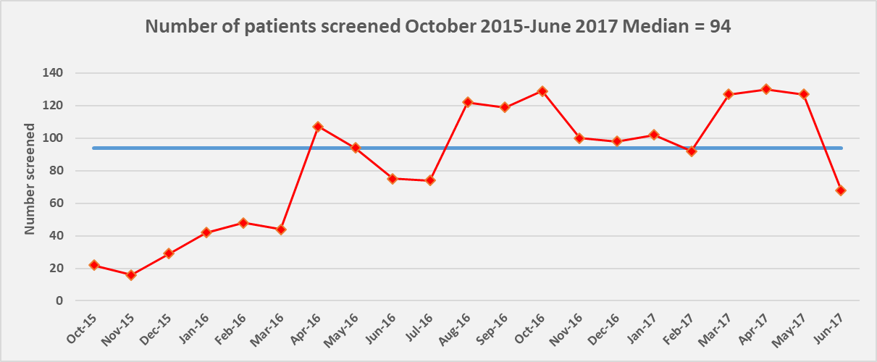
When time is your X axis, you can use either a bar chart or run chart for just a few data points. But if you have 6 or more data points over time, use the run chart format. The bar chart works best when the X axis is nominal data, e.g., clinic, provider, etc.
Pie charts
Pie charts display parts of a whole, and usually use color fields to distinguish between “slices” of the pie. Compare two pie charts using the same data collected to identify how a medical assistant uses his/her time.

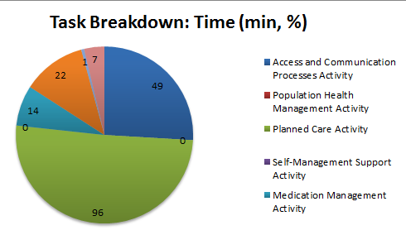
The legend lists five activities, but the pie has six slices. There is no title. The time is measured as both minutes and percentages of time. How much time in total? Are the labels minutes?

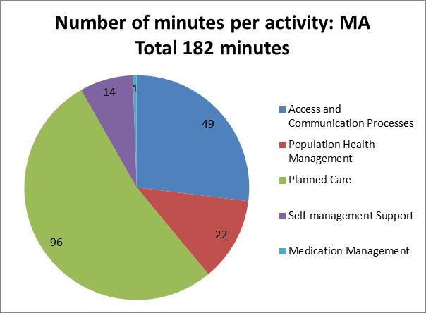
The title tells the story and gives a reference for the “whole” of the pie: 182 minutes in total (which would become the denominator if you wanted to talk about percent). Thus the slices are in minutes as well. The legend lists five activities and there are five slices.

Bar charts: simple

The bar chart can represent raw numbers or percents. However, percent can be deceiving without knowing the denominators. The bar chart works best when the X axis is nominal data, e.g., clinic, provider, etc. Clinic 1 could also be Week 1 of a five week trial. But if you have 6 or more data points over time, use the run chart format instead. Note that the Y axis is from 0% to 40% only to make clearer comparisons.

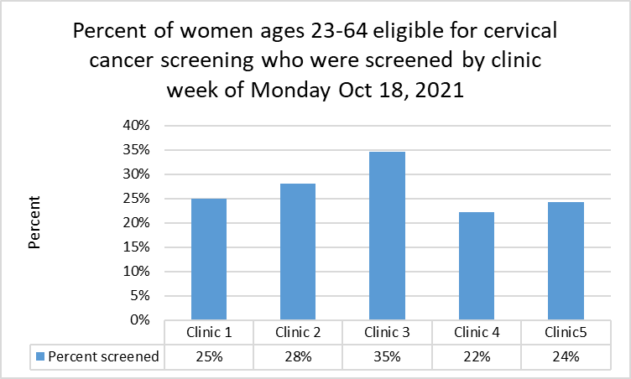

Bar graphs: stacked

Like a pie chart, a stacked bar graph gives you the whole and its parts. The X axis can be time (Q1, Q2), locations (Clinic A, Clinic B), names (Provider A, Provider B), etc. The Y axis and the data in the legend along the X axis in the examples below both display numbers. Note the titles are highly descriptive. Don’t mix numbers and percentages, that is, display one or the other. Again, percent can be deceiving without knowing the denominators. In the examples below, you can describe the data in more detail in a brief paragraph.

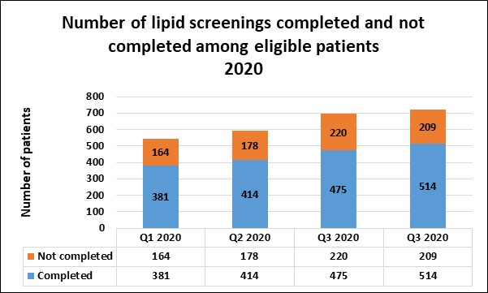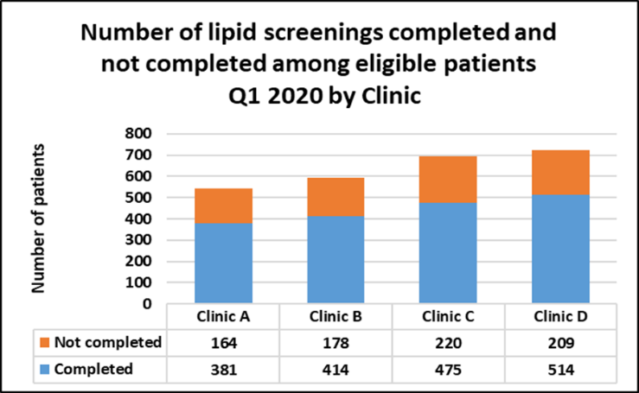

Side by side bar chart for comparisons

Side by side bar charts are a good way to compare Pre and Post scores, or to compare two clinics side by side within the same time frames. Note the titles are highly descriptive.

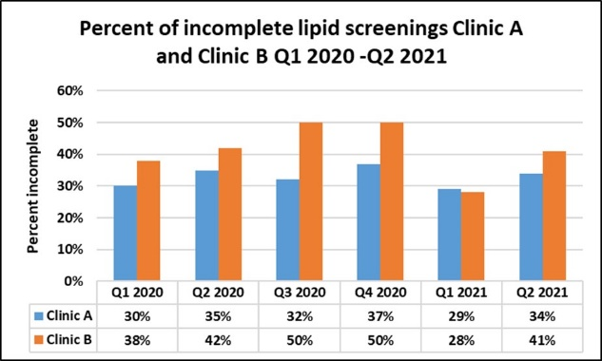
This is a side by side bar chart comparing incomplete screenings rates between two clinics over time. Beware of interpretation without context about size of population, staffing, etc. Percent can be deceiving without knowing the denominators.

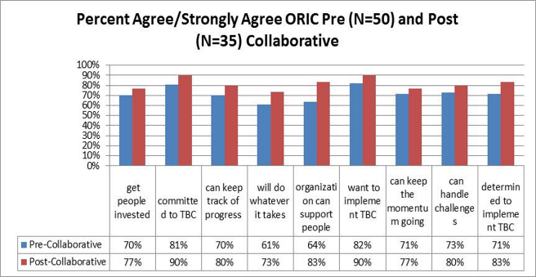
ORIC is a survey instrument. The X axis is the items on the survey. Note that the title gives the N for both Pre and Post. That is, the denominator is different for calculating percent agree/strongly agree Pre and Post.

