**CHCI Nurse Practitioner Residency**

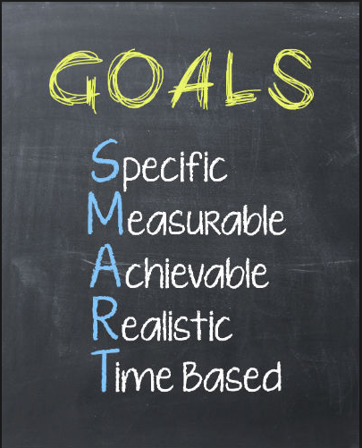

**Personal and Professional Development Plan**

Resident Name:

Date:

List two things you do well (one clinical, one professional):

1.

2.

List two things you would like to improve on (one clinical, one professional):

1.

2.

Set two short term goals that can be achieved in the next 6 months (one clinical, one professional):

1.

2.

Set one long term goal that can be achieved by the end of the residency:

Describe your strategies for achieving these goals:

Describe any potential opportunities or obstacles that you might encounter as your try to reach these goals:

Describe how you know if you have achieved these goals: