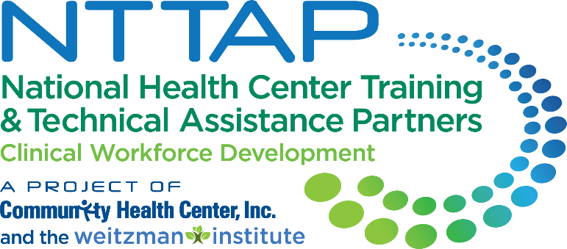**NTTAP Health Professions Student Training**

**Learning Collaborative**

**Storyboard Content Collection Tool**

The NTTAP team wants to help each health center tell the story of your involvement in the Health Professions Student Training Learning Collaborative through a showcase. This showcase process will allow each health center to compile the work you have done in this learning collaborative in a simple snapshot for you to share with other team members, leadership, partners, and more to help you continue to implement and improve your health professions student training program at your health center.

Showcase Purpose

* Tell the story of your health center’s work during this learning collaborative in a clean, crisp, visual format
* Generate reflection among you and the other team members about your involvement in this learning collaborative
* Share your work in future meetings with other health center staff including leadership and external stakeholders such as the health center board, community partners, and funders

Process

* Complete the “Response” column in the table below following the prompts in the “Showcase Section” column.
* Send your completed template to Meaghan Angers at [angersm@mwhs1.com](mailto:angersm@mwhs1.com) by Wednesday May 29th
* The NTTAP Team will edit and design the showcase using the content you provide.
* The NTTAP Team will send your draft storyboard by Thursday June 6th.
* Be prepared to share your showcase in the last in-person session on Tuesday June 11th at 3pm Eastern / 12pm Pacific.

Showcase Content Guidelines

* Complete all the required sections (*) and complete as many other sections as possible
* Please try and adhere to word count requirements.
* View the example showcases to see how your information will be shaped into a showcase.

**Showcase Content Collection Tool**

Due: Wednesday May 29th

Email to Meaghan Angers at [angersm@mwhs1.com](mailto:angersm@mwhs1.com)

* = required sections

|  |  |
| --- | --- |
| Storyboard Section | Response |
| **\*Innovations**   * *List 3-5 changes that demonstrate your health center’s movement toward implementing a health professions student training program.* * *90 words MAX* |  |
| **\* ‘Aha’ Moment(s)**   * *A “lightbulb” moment during this learning collaborative* * *70 words MAX* |  |
| **\*Recommendation(s) to others**   * *Provide up to 3 recommendations for others starting to implement a health professions student training program or in the learning collaborative* * *60 words MAX* |  |
| **\*Health Center Name and logo**   * *Type your health center name in the response box* * *Send to Meaghan Angers at angersm@mwhs1.com a high-resolution color logo (Do not send logo embedded in a Word document)* |  |
| **\*Health Center Description**   * *Provide a brief description of your health center* * *60 words MAX* |  |
| **Aim Statement**   * *Add your most up-to-date mission and vision for your health professions student training program.* * *90 words MAX* |  |
| **Program Drivers**   * *Add your most up-to-date program drivers for your health professions student training program.* * *90 words MAX* |  |
| **Measures/Impact**  *Looking at your data or Baseline Assessment, identify the most significant data point that highlights the importance of your work. You may use the results from the ORIC or RTAT self-assessment, which are available via Moodle.*   * *35 words MAX* |  |
| **Key Partners**  *Stakeholders related to the goals of this project:*   * *Internal: within the health center- (leadership, patient advisory groups)* * *External: outside of the health center (community organizations; schools; universities)* * *Do not include names – just titles and/or organizations* * *30 words MAX* |  |
| **Voice of the Team**  *Provide a brief statement from one of the team members about the impact of your project work*   * *List name of team member and job title* * *65 words MAX* |  |
| **Voice of Leadership**  *Provide a brief statement from a health center leader on the impact of your project work on the health center organization*   * *List name of leader and job title* * *Could use a quote from the application/letter of intent submitted for this learning community* * *65 words MAX* |  |
| **Process Map or other Visuals**   * *Visuals such as photos, graphs, or updated workflows/process maps.* * *This can include any of your work on the playbook* * *Must be in high-resolution jpeg or png format* * *Send to Meaghan Angers at angersm@mwhs1.com* |  |
| **Playbook**   * *Share any visuals, key findings, etc. from your playbook development* |  |
| **Other**  *Include any assignment you completed during the Collaborative that was a success to implement your health professions student training program.* |  |

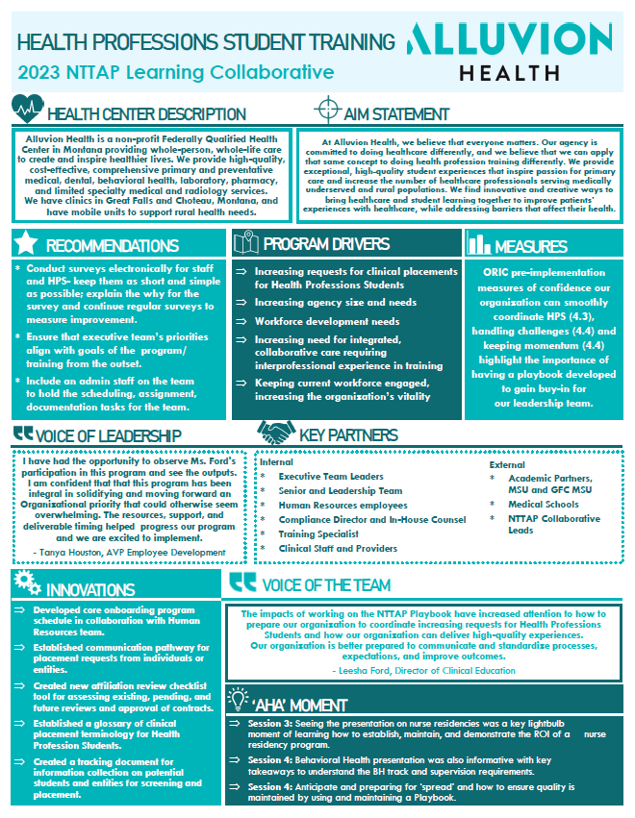**Example Showcase Template**

