**Ready, Set, PrEP** <https://www.getyourprep.com/>

**1-855-447-8410**

* **Government program that provides free oral PrEP medications to those who qualify.**
* **Patient can’t have ANY prescription insurance/benefit.**
* **Patient does not have to have SS# enter 0000 or 9999 for last 4 digits which is required field.**

**Electronic enrollment is faster (10-15 min). If pharmacy card doesn’t populate call the above #. If do as Healthcare Professional expedites process, if done as Individual Ready, Set, PrEP team has to reach out to provider first for consent. Patient will get immediate 30-day supply but then provider needs to authorize.**

**<https://www.hiv.gov/federal-response/ending-the-hiv-epidemic/prep-program>**

**Other options are forms (takes longer):**

**English version:**

<https://readysetprep.hiv.gov/GSMISC1924_HHS_EHE_Enrollment_Revised%20(006)_v6_20210712_Fillable-protected.pdf>

**Spanish version:**

<https://readysetprep.hiv.gov/GSMISC1924_HHS_EHE_Enrollment_Form_Spanish_Revised_20210715_Fillable-protected.pdf>



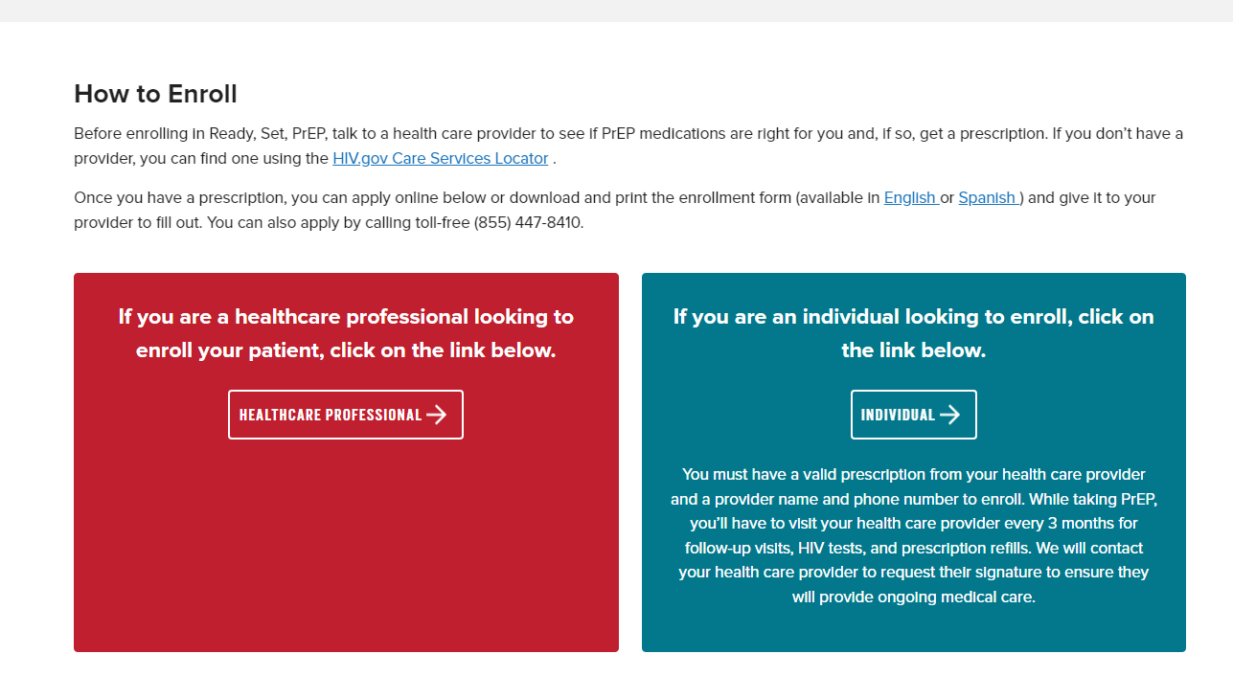

**Oral Medication Assistance (brand Truvada & Descovy)**

**Gilead Advanced Access Program** <https://www.gileadadvancingaccess.com/>

**Co-Pay Card**

If you have private insurance, card covers up to $7,200 per year towards the cost of Truvada or Descovy, with no monthly limit. It can be used for copays, coinsurance, or high deductibles.

Patients that have government insurance (Medicare D, Medicaid, TRICARE) are not eligible.

**Gilead Advanced Access Program** <https://www.gileadadvancingaccess.com/>

**Patient Assistance Program (PAP)**

**No insurance**

Copy of form: <https://services.gileadhiv.com/content/pdf/gilead_enrollment_form.pdf>

Advancing Access is a program that assists uninsured, underinsured, and some Medicare patients by covering the costs (or gaps in cost) for Truvada or Descovy. Patients must have income < 500% of the Federal Poverty Level qualify.

What is needed: social security number (?), proof of income (W2, 1040 tax return, 2 most recent pay stubs, or a notarized letter with monthly income, Medicaid denial letter)

*Gilead Advancing Access may be able to help provide information about financial support through alternative sources of funding.

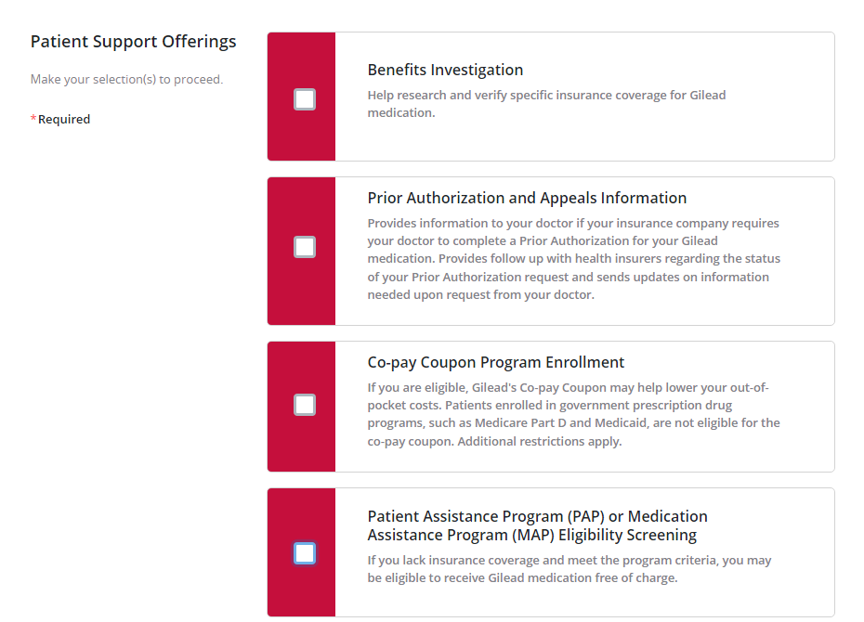

**Taken from:** [**https://advancingaccessconsent.iassist.com/service-type**](https://advancingaccessconsent.iassist.com/service-type)

**340B Drug Discount Program**

* Cost of Truvada generic emtricitabine/tenofovir 200-300mg (Aurobindo manufacturer) for 30 days is ~$5.00 plus any additional costs like pharmacy dispensing and admin fee. The manufacturer (NDC) matters!
* Some organizations can use establish sliding scale for PrEP meds at in-house or contract pharmacies
* Providing PrEP medication may be possible using 340B revenue

**Long-Acting Injection Assistance**

**Apretude (cabotegravir) -ViiV**

Apretude (cabotegravir) is a long acting injectable medication for HIV prevention. The injection have to be delivered/shipped to and administered at clinic. A patient or representative (including a VN) cannot get directly from the pharmacy. This is a limited distribution drug so only select pharmacies can dispense. It does not have to be refrigerated.

Copay Assistance:

<https://www.apretudecopayprogram.com/>

ViiV Patient Assistant Programs:

<https://www.viivconnect.com/for-providers/viivconnect-programs/medications/>

Apretude Injection Video:

<https://www.youtube.com/watch/y56SDmcMS8M>

Dosing Guide:

<https://apretudehcp.com/dosing/>

**Long-Acting Injection Assistance**

**Apretude (cabotegravir) -ViiV**

\***ViiV Field Reimbursement Managers are helpful, would avoid ViiVConnect**

[Speak to a Resource | APRETUDE (cabotegravir 200 mg/mL) (apretudehcp.com)](https://urldefense.com/v3/__https:/apretudehcp.com/speak-to-a-resource/__;!!CfiprD0C6IEL0SLVhA0!tfgmTTpNR-15p9kLHLrnjetjUbomBbwTStxeXzTxx_Hl-NHn2gXynmKqyWNiVWIpqqCHFcL2C3Yvt2UULgthJ8IAUVmwQw$)

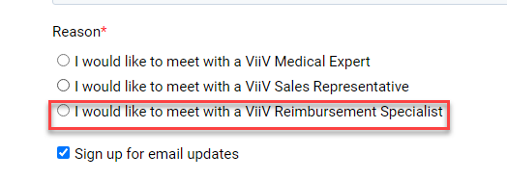

**Some Best Practice Suggestions**

* **Find a source to get meds that will be collaborative. This helps w/ prior authorizations, deliveries/shipment, determining if insurance patients have to use specific pharmacy. Ensures patients are treated w/ respect they deserve.**
* **Remember access for each patient will be different and can change over time**
* **Have information that can be updated available for anyone in the organization to reference (shared drive, internal website). Always use link to forms/site so most current data is there.**
* **Start small and expand new workflows/services after pain points are identified**
* **Have clinical and site champions**