EXAMPLE PLAN DO STUDY ACT (PDSA) FORM
FOR LEARNING COLLABORATIVE SERIES
PDSA Cycle #: 1

QI Initiative: Increase the number of diabetes panels ordered
QI Lead(s): Dr. John Smith, Nancy Jones

Clinic: Western FQHC
Timeline: 01/01/25 to 03/31/25
Objective of Cycle:

Develop a Change X Test a Change Implement a Change

Aim Statement (WHAT YOU ARE TRYING TO ACCOMPLISH): We aim to increase the number of diabetes panels ordered by ensuring clinicians are aware of the importance of routine DM testing for patients with overweight/obesity
Goals: Our goal is for clinicians to order diabetes panels for at least 100 patients with a BMI >25 within 1 month
Steps: We will place reminder signs in the clinic and provide brief educational sessions to clinicians on the importance of ordering DM panels for obese patients

- Specific- targeted population: Focus on the least 100 patients with a BMI >25 for an upcoming appointment in the next 1 month and continue for the next 3 months.

- Measurable- what to measure and clearly stated goal: Use a dashboard to track the number of DM panels ordered for the specific target populations each month

- Achievable- brief plan to accomplish it: Include tracking metrics in EMR [BMI, DM panel ordered, etc] and EMR alert reminders to notify the care team when these patients return to the clinic.

- Relevant- why is it important to do now: Several patients who are overweight/obese have comorbidities, including DM. By identifying these patients earlier, ordering DM panels, and working with patients and the care team to create care plans we will be able to see improvements in patient outcomes (ex. BMI, A1C, etc).

- Time Specific- anticipated length of cycle: The team will test over the next 2-3 months, review data and continue through the PDSA cycle to determine success and next steps for the next PDSA cycle of improvement.

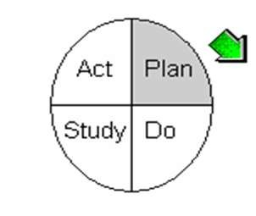
PLAN

Test/Implementation Plan (THINK ABOUT YOUR CURRENT PRACTICES/PROCCESS AND REFLECT ON WHAT CHANGES YOU CAN MAKE THAT WILL RESULT IN IMPROVEMENT AND WHAT YOU WILL NEED TO ACHIEVE YOUR AIM):

Current Practices/Process Related to QI Initiative:
- We are currently tracking BMI, but unsure how consistently this is being done across teams
- We do not have an alert or standing order for all patients with a BMI over 25 to have a DM panel ordered

Prediction: What change will be tested or implemented? Include how change will be conducted, who will run it, where it will be run and when it will be run unless already noted in Aim Statement above. (If needed, include specifics on tasks, responsibilities and due dates.)

- We will test the identification of patients by each care team, addition of EMR alerts, and DM panels ordered
- The physician and nurse should be the lead to make sure this is happening with the care team at the clinical visit.
  - The physician will discuss ordering the DM panel with the patient
  - The nurse will make sure the order has been sent or the patient has the order or the CMA does the blood draw onsite to send through our labs.

Anticipated Barriers:
- Some providers notice and respond to alerts. If they do not, their care team members may not feel comfortable bringing up the missed alert
- It may take the QI or care team time to identify patients for the specific target prior to them coming into the clinic.
- Patients may no show or reschedule
- Time constraints and busy clinical days
Anticipated Resources (ex., training, patient education, staffing, EMR updates, EMR data tracking/pulls, etc):
- Educate providers and the care team about the alerts and that it is the responsibility of all members of the team to highlight if an alert has been missed prior to the patient leaving
- A process with a timeline may need to be created to make sure identifying patients happens consistently across teams
- If patients no show, consider a process for follow-up and/or when appointment is rescheduled. Process could include sending the order for the patient to have DM panel completed prior to the rescheduled visit.
- Sending patient reminders for no shows/rescheduling
- Time/ staff to pull EMR data and review it at monthly clinic/care team meetings to assess progress, feedback, and any concerns
Data Collection Plan (THINK ABOUT HOW YOU WILL KNOW THE CHANGE IS AN IMPROVEMENT):

What data/measures will be collected?
- Number of patients identified for next 1 to 3 months
- BMI updated on these patients
- DM orders on these patients
- Number of alerts ignored by providers/care team
- Notes from data review to assess progress, feedback, and any concerns from the team
Who will collect the data?
- Ask our QI person to track data [Visit type, BMI, DM Panel orders, CPT codes…]
- Ask care team members to track any feedback/concerns to share
- I will compile data and notes during review sessions to keep track each month.
When will the collection of data take place and how often will you/your team review the data?
- Data will be collected each month for the team to review. Will ask QI person to collect it the final week of the month to review the first week of the next month with the tea
How will the data (measures or observations) be collected and displayed?
- Collected via the QI person and notes shared by team. Results will be shared with care teams and potentially in the clinic space to help motivate staff and encourage friendly competition across teams.
What decisions will be made based on data?
- Data will be used to address concerns, evaluate missed opportunities, and identify reinforcements such as reminders and repeat education and/or small celebrations of success.

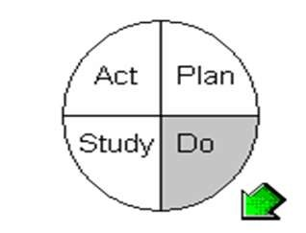
DO

Activities/Observations:

Record activities/observations that were done in addition to those listed in plan (above):

- Of 300 patients, only 60 DM panels (20%) were ordered, falling well short of our goal
- The reminders were not sufficient to significantly change ordering behavior
- Repeat training was provided for care teams but was not conducted immediately upon new staff hires.
- Teams appreciated seeing how other teams were doing and the ability to share feedback
- Care team members provided feedback that discussing alerts with the care team at morning huddles would be beneficial as an additional reminder.
- Additional notes and data files/ trend graphs will be attached to team email and/or pasted below.
How will your team sustain changes that have been tested and are ready to be fully implemented throughout your organization?
- Standardize process
  - Integrate these processes into existing documentation systems (e.g., EHR templates).
- Build a culture of accountability
  - Assign process owners who will monitor compliance with the new processes.
- Provide training and education for key stakeholders
  - Create easy-to-access reference guides and hold refresher training sessions periodically
- Incorporate monitoring and metrics
  - Implement data dashboards visible to staff to provide real-time feedback on performance.
- Celebrate success and maintain morale
  - Share success stories to build momentum and reinforce the benefits of sustaining the changes

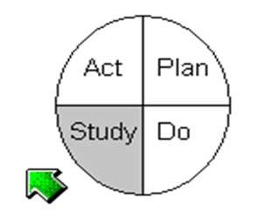
STUDY
Questions: Copy and paste Prediction from Plan above and evaluate learning. Complete analysis of the data. Insert graphic analysis whenever possible.
Prediction:
Learning (Comparison of questions, predictions, and analysis of data):

  - Patients were identified by care team members, only 1 care team had some delays in the beginning
  - EMR alerts were added, but 2 providers often ignored them.
  - Of 300 patients, only 60 DM panels (20%) were ordered, falling well short of our goal
  - Physician and nurses took the lead, but CMAs were very helpful letting the team know when they might miss the alert.
  - Some patients were receptive to getting blood work done before, but there were still no-show issues and non-compliance

Summary (Look at your data. Did the change lead to improvement? Why or why not? What else could have been done to see an improvement?):

  - There was some improvement across teams, but it was small and not all teams saw an improvement.
  - The reminders were not sufficient to significantly change ordering behavior
  - Repeat training was provided for care teams but was not conducted immediately upon new staff hires.
  - Teams appreciated seeing how other teams were doing and the ability to share feedback
  - Care team members provided feedback that discussing alerts with the care team at morning huddles would be beneficial as an additional reminder.

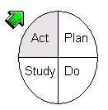
ACT

Describe next PDSA Cycle: Based on the learning in “Study,” what will your next PDSA cycle focus on improving?
- Focusing on different ways to remind the team, similar to the suggestion for actively discussing it with the care team at morning huddles
- Consider registration asking patients if they would like to schedule or get their DM panel as a final stop gap before the patient leaves
- Identifying ways to empower the CMAs to champion the initiative since they most often caught missed opportunities, as well as next steps after they discuss it with the nurse and/or provider.

