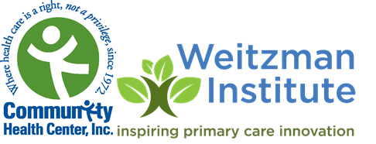

**ADD high res LOGO**

**FOR IMMEDIATE RELEASE**

**DATE:**

**For more information contact:**

**PLEASE ADD INFO:**

**Organization NAME Launches Postgraduate Residency Training Program for Family Nurse Practitioners**

*Organization Name*  is pleased to announce the launch of a Family Nurse Practitioner Residency Training Program. This residency program will provide intensive training in both the clinical complexity of family practice in the safety net/rural setting, and training in the Patient Centered Medical Home model for primary care.

“We are thrilled to launch this Nurse Practitioner Residency Program,” said , *Organization Name ‘s*  Chief Executive Officer“ This program will equip new family nurse practitioners with the skills they need to care for underserved populations and assume future leadership roles in community health care.”

The primary goals of this program include:

* Increase access to quality primary care for underserved, rural and special populations,
* Provide new Family Nurse Practitioners with a depth, breadth, volume and intensity of clinical training necessary to serve as primary care providers in the complex setting of the country’s Federally Qualified Health Centers
* Improve the skills, confidence, productivity, and job satisfaction of new nurse practitioners, specifically in a rural setting
* Increase the number of Nurse Practitioners ready to serve in leadership roles in community health centers

“The residency program is specifically intended for family nurse practitioners who are committed to developing careers as primary care providers in the challenging setting of community health centers and other safety net settings**”** *Organization Name* **CNO or CMO** (Confirm or add contact) “The program includes precepted primary care sessions, specialty rotations, mentored independent clinics in a rural setting, weekly didactic sessions and participation in Project ECHO and quality improvement training.”

Three (confirm #) residency slots are available for the inaugural 2022-2023 Nurse Practitioner Residency Class. For more information please visit our website at [ADD](http://www.hrhcare.org/npresidency) INFO.

For more information about the residency program, please contact: ADD INFO- please set up NP residency email address ASAP.

**About Yakima Neighborhood Health Services**

Add n).

For full information: **https://www._____ or call** [(XXX)](tel:(617)%20533-2300) XXX-XXXX