NTTAP Comprehensive and Team-Based Care Learning Collaborative
Quality Improvement Workbook 2024-2025

Welcome
Welcome to the Comprehensive and Team-Based Care Learning Collaborative offered by Community Health Center, Inc.’s National Training and Technical Assistance Partners (NTTAP) on Clinical Workforce Development funded by the Health Resources and Services Administration (HRSA).
This workbook is designed to accompany the Comprehensive and Team-Based Care Learning Collaborative. It will guide you step-by-step to use quality improvement (QI) methods to help you learn about how your practice works to make process improvements and integrate best practices. This workbook accompanies our new book, Team-Based Primary Care in Health Centers, and give you a greater understanding of our quality improvement methods and the principles of team-based care. It will include explanations, examples, and templates. By completing the templates in the Quality Improvement workbook, you will be able to keep all completed deliverables in one place. This Quality Improvement workbook will follow the pace and syllabus for the Comprehensive and Team-Based Care Learning Collaborative.
We hope that you will find this to be a valuable resource!
Table of Contents

Introduction 2
Step 1: Team and Roles Defined 4
Step 2: Assessment and Baseline Data 7
Step 3: Global Aim 10
Step 4: Problem Statement 12
Step 5: Specific Aims and Measures 16
Step 6: Solution Storming and Change Ideas 20
Step 7: PDSA 21
Step 8: SDSA – Test the “New Process” with Another Teamlet 24
Step 9: Spread/Standardize the “New Process”, Measure, and Monitor 26
Appendix A: Data Displays 27
Appendix B: Data Collection Plan 29
Appendix C: Detailing the Whole Process – Breast Cancer Screening 31

This project is supported by the Health Resources and Services Administration (HRSA) of the U.S. Department of Health and Human Services (HHS) as part of an award totaling $550,000 with 0% financed with non-governmental sources. The contents are those of the author(s) and do not necessarily represent the official views of, nor an endorsement, by HRSA, HHS, or the U.S. Government. For more information, please visit HRSA.gov.

Introduction
We subscribe to the Clinical Microsystems quality improvement approach, developed at The Dartmouth Institute for Health Policy and Clinical Practice, which is now known as The Microsystems Academy (https://clinicalmicrosystem.org/). Clinical Microsystems uses many of the same tools as Lean, Six Sigma, and the model developed by the Institute for Healthcare Improvement, such as aim statements, fishbone diagrams, and Plan-Do-Study-Act cycles, but there are important differences:
- A clinical microsystem in health care is “a small group of people who work together on a regular basis to provide care to discrete subpopulations of patients. It has clinical and business aims, linked processes, and a shared information environment, and it produces performance outcomes” (Nelson, et al., 2002, p. 474). A core team in primary care acts as a clinical microsystem.
- Clinical Microsystems is built on the premise that the people who do the work, that is, the clinical team, know how to improve it, which is consistent with the principles of team-based care. That is, improvement begins where improvement is needed, with the staff. Improvement ideas are not handed down from administration; rather, it is the role of administration to provide support for improvement efforts, which can include time, resources (like data, experts), and guidance about how improvement efforts would fit within the larger organization.
Our adaptation of the Clinical Microsystems Improvement Ramp is on the following page. Although we will refer to steps in the improvement ramp, it is NOT a linear step-wise process. You may be working on a specific aim (Step 5) only to realize that you don’t have sufficient data, and so go back to assess your practice again (Step 2). You might work on your Global Aim (Step 3) and your Problem Statement (Step 4) at the same time, as one may help you to clarify the other. It is best to cover all of the steps in the ramp and use the tools that are appropriate for your work. See Figure 1 for the Stages of the Improvement Ramp.
For additional resources:
Team-Based Primary Care in Health Centers book
Evaluation of a learning collaborative to advance team-based care in Federally Qualified Health Centers
Building Teams in Primary Care: A Practical Guide
Teamlets in Primary Care: Enhancing the Patient and Clinician Experience
Anatomy and Physiology of Primary Care Teams
Building Powerful Primary Care Teams
The Teamlet Model of Primary Care

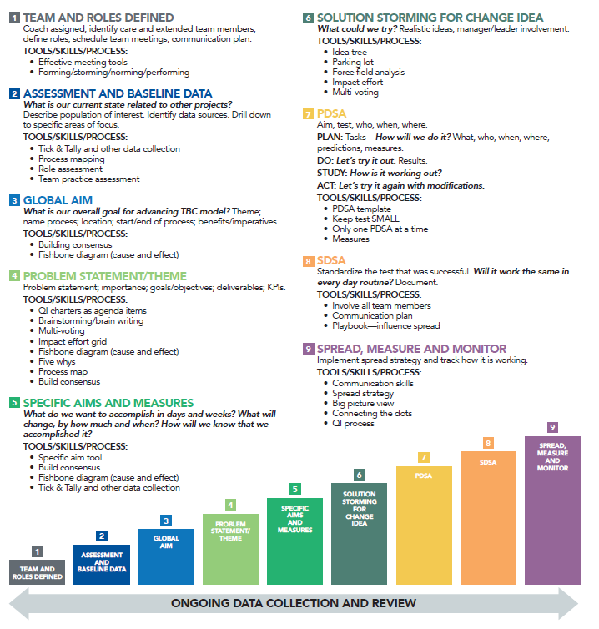
Figure 1. Stages of Improvement Ramp

Step 1: Team and Roles Defined
Overview
For the Comprehensive and Team-Based Care Learning Collaborative, you will need to define your team and the roles of the team members. These teams and roles include:
- A teamlet consists of the provider and a medical assistant who work together on a regular basis caring for a panel of patients. If you do not have a teamlet now, we suggest that you do your best to create one moving forward. If you do not have a medical assistant, choose someone with whom the provider works day-to-day and is patient-facing, such as a nurse. The teamlet is part of the core team.
- Core team is a group of people who work together on a regular basis to care for a panel of patients. If they don’t work together on a regular basis now, choose people who you want to work together as a team going forward. Along with the teamlet, this may include front desk staff/scheduler, nurse, manager, and/or others as appropriate to your practice. These are the people who do the work of patient care and so are in the best position to change how they work together. The members of the core team will ideally meet weekly for an hour to make progress on deliverable items, as well as attend or watch the monthly 90-minute learning sessions.
- Extended team is the group of people who support multiple teams and so will be your resources. They will attend your regularly scheduled team meetings as needed, as well as attend or watch the monthly 90-minute learning sessions as needed. The extend team can include a behavioral health provider, social worker, business intelligence/IT staff, QI staff, administrators, human resources, and/or others as appropriate to your practice. This may also include health center leadership, such as the CEO and/or CMO. The composition will vary depending on your practice setting.
- The team leader (or co-team leaders) is responsible for supporting the team in following timelines, completing deliverables, ensuring the team is meeting on a regular basis, and progress reporting in weekly 60-minute team leader check-in calls. As needed, the team leader will also communicate progress with health center leadership.
Note: We find that team composition does change during the first few weeks as you determine your quality improvement project focus.

KEY POINT: You must establish clarity of purpose at the start to make your team work. Here is what to say:
“The purpose of the Comprehensive and Team-Based Care Learning Collaborative is twofold. One, we will learn about the principles of team-based care from Dr. Tom Bodenheimer, who is at the Center for Excellence in Primary Care at the University of California San Francisco (https://cepc.ucsf.edu/ ), and from the staff at Community Health Center in Connecticut, who have been practicing team-based care for years. Two, we are going to use quality improvement tools to systematically improve at least one aspect of our practice as a way to start implementing team-based care. We will decide what aspect to work on when we assess our practice, which means using data because team-based care is data-driven. We all have different roles but we need to learn to improve our practice and implement team-based care together. The Collaborative is just the beginning of our work – it is not a one-time initiative. It is designed to set us up for success to continue to implement team-based care when the learning collaborative has concluded.”
Stakeholder Analysis
Different stakeholders need different types of information about your work, and with different levels of detail. As an innovator, you have to manage the relationships between your group and the stakeholders, and sometimes among the stakeholders. Think in terms of lateral and vertical relationships, that is, peers as well as those you report to and those who report to you: your boss, your staff, your peers, managers, leaders, other departments. Figure 2 analyzes stakeholders by the power they have to support innovation and their interest in your innovation. The higher their power and interest, the more closely you need to engage with those stakeholders.
Figure 2. Stakeholder analysis: Who do you need to communicate with and Why?
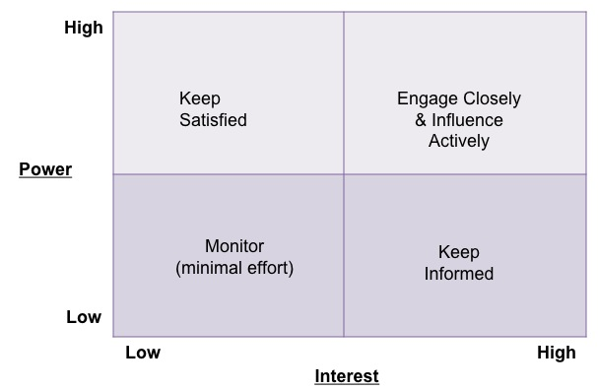

When you create your own and enter each name, ask yourselves these questions:
- Why is this person a stakeholder?
- What does this person know about your current project?
- What is their opinion of your current project? Supportive? Opposed? Neutral?
- What are the formal channels through which this person gets important information?

Deliverable – Stakeholder Analysis Template

Keep Satisfied

Engage Closely & Influence Actively

Monitor

Keep Informed

Communication Plan
A communication plan lays out who, what, when, where, why, how of engaging with stakeholders, and ensure that you are doing so. When you are communicating with someone who is above you in a leadership position, this is referred to as managing up. You have to manage their expectations for the work you are doing, but also manage the relationship between this person and the work group. See below for an example:
COMMUNICATION PLAN – IMPORTANT PROJECT
DATE: November 2023
PROJECT LEAD: Mrs. Peacock
Who: Stakeholder | Why communicate with this person? | What: Message(s) for this person | Who: Who in your project group will communicate with this person? | When and how often? | How: What venues or media will be used?
Mr. Green, CEO | Has invested in time for us to meet.  Will need his/ her support to implement the innovation. | Assure him/her that we are using time well.  Update on progress of group, lessons learned from other groups, ideas for implementation and application.  Keep good energy.  Don’t: tattle or report on internal group dynamics, keep that amongst the group. | Colonel Mustard, Director of Big Department and Project Lead | Monthly meeting of directors.  One-on-one meetings as appropriate to request resources as needed or ask advice. | Oral report monthly but written report added to meeting minutes.

Deliverable – Communication Plan Template
COMMUNICATION PLAN – [PROJECT NAME]
DATE:
PROJECT LEAD:
Who: Stakeholder | Why communicate with this person? | What: Message(s) for this person | Who: Who in your project group will communicate with this person? | When and how often? | How: What venues or media will be used?

Step 2: Assessment and Baseline Data
Overview
Team-based care is data driven. Without data about your current practice as a baseline, you can’t measure improvement. In our collaboratives, we ask teams to measure changes in their practice, and thus it is important to become familiar with how data is defined, collected, and used. However, in our experience working with teams from around the country, we found that many struggled with data as they developed their global and specific aim statements, and as they measured change during Plan-Do-Study-Act-cycles. The data often came from reports pulled from electronic health records by information technology and/or business intelligence personnel. Some organizations have internal staff in these departments, while others outsource data management to vendors. Most often, data is used to report quality improvement indicators, such as Uniform Data System (UDS) or National Committee for Quality Assurance (NCQA) measures. Frontline teams may or may not see these reports, and when they do, have no context for what they mean.

KEY POINT: It will be important to work with administration and business intelligence/information technology to get the data that you will need for this project. See Appendix A for data displays.

About Data
There are many kinds of data, and the type of data you have determines how you can use it to measure performance. Most of your data, such as UDS measures, is ratio quantitative data in which you count numbers of patients, events (no-show rates), objects (syringes), and so on.
Table 1. Ratio quantitative data
Definition and uses | Ratio data are raw numbers with a natural zero.
Why it matters | Can be added, subtracted, multiplied and divided. This is important for some statistical tests and run charts.
Example | You can have “zero” patients screened.  10 patients screened is two times 5 patients screened.  You can have an average number of patients over the course of three months: 26+ 37+31= 92÷3 = 30.6.
Counting vs. measuring | When counting, you use whole numbers: you can count 2 patients, but you can’t count 2 ½ patients.  When measuring, you can have fractions: ½ cup.  Technically, time is measured, not counted. Yes, you can count up to 1 ½ minutes which is half of 3 minutes. But because time is not measured in base 10 (there are not 100 minutes in an hour), calculations in excel, run charts or other statistical tests require different formulas than most ratio data. This is important if you are studying cycle time, for example.
Types of practice data
In order to improve patient and quality outcomes, you need to change the structure (e.g., team composition, templates in the EMR) and care delivery processes (workflows) of your day to day practice. The graphic from Donabedian below illustrates the concept of structure-process-outcomes. Many people become impatient with process, but without process, there are no outcomes and without structure, there are no processes.
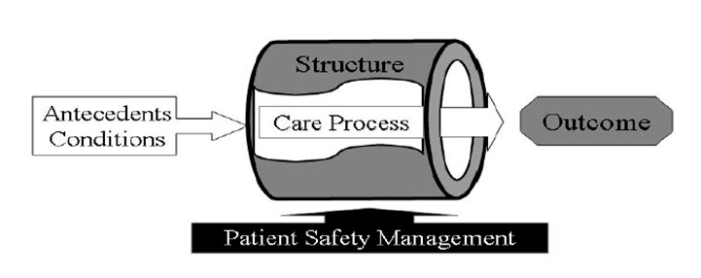
Structure: Physical and organizational characteristics of where health care occurs/ Capacity and systems in place to provide care
- Examples: Space, staffing ratios, Panel Size, Pods, core teams, EMR
- Some sources for you: Practice Assessment Guide

Process measures: How care is delivered to patients/What happens to ensure care is delivered/ what staff do
- Examples: screening rate for cancer, cycle time, no show rates
- Sources: Role Activity Analysis

Outcome measures: Effects/ results of health care delivery on the status of patients and patient populations
- Examples: percent of population screened for breast cancer
- Sources: UDS measures

Define your data
Population: In this workbook, we will use the UDS measure for breast cancer screening as an example. The population is women [assigned female at birth] ages 50-74 who are eligible for a mammogram to screen for breast cancer in the 27 months prior to the end of the measurement period. The population is your denominator. For UDS measures, the definition of the population is pre-determined by the national organizations to which the data is submitted. Defining the denominator can be the most difficult part of determining percentages and rates.
Samples/subsets: Your population may be broken down into two or more mutually exclusive subsets, i.e., groups or categories, using pre-determined attributes, such as time, place, age, gender, diagnosis, and so on. For example, the population of women ages 50-74 is divided further into A) screened or B) not screened. A patient can only fit into A or B, never both. For this UDS measure, A is your numerator. The population can be further divided by age and screening status, or screening status and panel—whatever you decide is your numerator. Table 2 is an example of defining your population and one subset(s) using the UDS measure for breast cancer screening.
Table 2. What’s our breast cancer screening rate?
Definition of UDS measure | Percentage of women 50 –74 years of age who had a mammogram to screen for breast cancer in the 27 months prior to the end of the measurement period
Population (denominator) | Number of women 50 –74 years of age who were eligible for a mammogram to screen for breast cancer in the 27 months prior to the end of the measurement period (N=100)
Subsets | A: number of women whose mammogram is documented in EMR (n=42)  B: number of women whose mammogram is NOT documented in EMR (n=58)
Measurement period | First quarter of 2025: January/February/March
Source of data/evidence | As documented in the EMR
Numerator | Subset A: Number of women 50 –74 years of age who were eligible for a mammogram to screen for breast cancer in the 27 months prior to the end of the measurement period whose mammogram is documented in EMR* (n=42)
Denominator | Population: Number of women 50 –74 years of age who were eligible for a mammogram to screen for breast cancer in the 27 months prior to the end of the measurement period (N=100)
Rate | Numerator/Denominator=42/100=42%
* If it is not documented in the EMR, it did not happen! Check to be sure that your (EMR) collects the data in a way that is consistent with the definition you are using to sort your patients into groups.
KEY PONT: If you can’t define your data sets, you can’t measure them. It’s all about the definition! See Appendix A for data displays.
Deliverable – Define Your Baseline Data
Definition of UDS measure
Population (denominator)
Subsets
Measurement period
Source of data/evidence
Numerator
Denominator
Rate

Deliverable – Self-Assessments
- As a team, complete the Primary Care Team Guide Self-Assessment
- Ask the team leader(s) to complete the Team Leader Self-Assessment Skills
- Ask each team member to complete the Team Member Self-Assessment Skills
- As a team, complete the Role Activity Assessment Tool – download template under “Additional Information” here

Step 3: Global Aim
Overview
The Global Aim is broad, and is based on a general problem or area for improvement that you have identified, but have not yet determined what strategies you will take to make that improvement or how you will measure success. It describes what you aim to improve and where and why, but it does not go into how or by how much. You want to choose ONE clinical process that needs improvement based on your practice assessment. It has to be doable for you as a team, and preferably a process that involves multiple team roles. Measures, such as cancer screenings, are good topics because they involve multiple roles in the workflow.

KEY POINT: Pick one measure.
By picking ONE measure, you will learn the process of involving your team in improving your practice, and that can be applied to other team efforts going forward.
Choose a clinical process with a beginning, a middle, and an end over which you have some control because you will be designing PDSAs to improve it.
The process is something that you do, it is observable and hands on; it is not the outcome.
The process starts when someone does something. Very often the process starts with identifying your patient population. Who does that? If you are using a UDS or other standardized measure, the process will end with documentation in the patient’s record because that is where your data will come from.

Helpful Tips
- Global aims DO NOT include any data.
- Global aims DO NOT include a strategy, e.g., “we will improve breast cancer screening rate by doing [this or that].” Save strategies for the PDSA.
- Avoid global aims that are too broad and/or are not based on an assessment of your practice and/or are not measurable, e.g., “communication” or “improve efficiency.”
- Make sure to identify the location and panel of patients.
- A clinical process begins and ends when someone does something. Who does what to get it started? Who does what to complete it?
- Don’t confuse the clinical process with the improvement process, e.g., the clinical process ends with documentation in the patient record whereas the improvement process ends with an increase in screening rates.

Deliverable – Global Aim Template
Theme for improvement:
We aim to improve:
In:
The process begins with:
The process ends with:
By working on the process, we expect:
It’s important to work on this now because:

Global Aim Example
Theme for improvement: Based on your practice assessment
- Example: UDS measure for breast cancer screening.
We aim to improve: Name the process
- Example: the process for breast cancer screening
In: Clinical location in which process is embedded
- Example: Dr. Smith’s panel at the Main St. Clinic.
The process begins with: Name where the process begins
- Example: identifying patients who are eligible for screening.
The process ends with: Name the ending point of the process
- Example: documenting in the patient’s health record that screening has occurred.
By working on the process, we expect:
- Example: to improve the UDS measure for breast cancer screening rate
It’s important to work on this now because:
- Example: Our current rate for breast cancer screening is in the 3rd quartile so we can’t take advantage of value-based reimbursements. Our rate has declined, but we have a lot of new staff and so have an opportunity to get a standardized workflow in place. We need to be better about making sure that our patients are being screened as the incidence of breast cancer in our population is higher than average. We’re pretty good about ordering the mammograms, but we don’t do mammograms at our clinic so we need to get better at having them documented in our records.

Step 4: Problem Statement
Overview – Define the Problem
The problem statement and global aim go together. In order to identify the problem, you need to do two things:
- Assess your practice using data. This can include your baseline UDS data, the results of the Practice Assessment Guide and the Role Activity Assessment, and doing process mapping and a fishbone diagram with your team.
- Talk to stakeholders.
Problem Example: We aim to improve the process for screening for breast cancer because our UDS measure is currently in the 3rd percentile. There seem to be two main issues: (1) the mammogram is not ordered at the time of the patient’s visit, and (2) the test results are not documented in the chart. We don’t know if #2 is because the patient did not follow through with an appointment or because the results were not sent to us by the external mammography center.
This example gives you some strategies to try later: ensuring that the mammogram is ordered, ensuring the patient made and kept an appointment, and ensuring that the results are documented in the chart. What team members are involved and how can you optimize their role to accomplish your aim? Who does what when and how?
Process Map Overview
A process map visually shows the steps of a work activity and the people who are involved in carrying out each step. It is a sequence of detailed steps for a specific purpose. Process Maps:
- Show the current process, NOT the ideal process
- Reveal unwanted variation, waste, delays, and duplicate work
- Build teamwork: different team members will have different perspectives on what actually happens—which is the point of the exercise
- Generate ideas for improvement
7 Steps to Process Mapping
- Identify the process you need to map – Whether it’s a process that is underperforming or important to a new strategy identify it and give it a name
- Bring together the right team – Bring together everyone involved in doing, managing and providing input to the process
- Brainstorm the process steps – Gather all information from start to end: steps, inputs, outputs, roles, time durations etc.
- Organize the process steps – Take the steps you identified earlier and arrange them in a sequential order
- Draw the baseline process map – Beginning from the start, draw a map that shows the process in its current state
- Identify areas for improvement – Identify bottlenecks and inefficiencies within the process and plan for improvements
- Implement & monitor improvements – Implement improvements on a smaller scale and monitor the results before standardizing them
Process Map Shapes
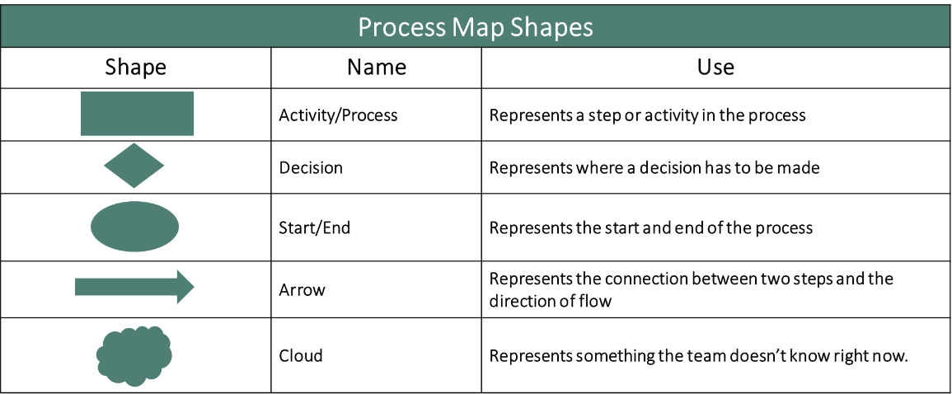
Helpful Tips
- Process Maps should NOT be too complicated! Try to be concise and not overwhelm the reader. Consider more than one map if there are too many contingencies.
- Update Process Maps regularly. Set a schedule for updates to process maps to avoid confusion or providing outdated information.
- Take the time to thoughtfully and carefully create the Process Map. Don’t rush the process of developing the Process Map – it may take several meetings.
- Use a standard and consistent language/shape formula for process maps.
- Develop specificity very carefully – Try not to be too specific while also being specific enough to provide adequate information to use the process.
Process Map Example

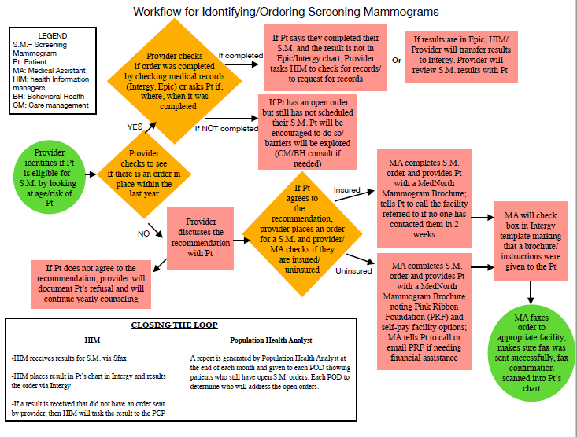

Deliverable – Complete your Process Map for your current process
Download the template under “Additional Information” here

Fishbone Diagram Overview
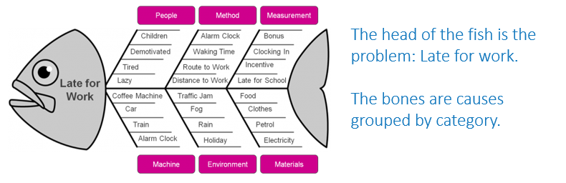
A Fishbone Diagram is a cause and effect diagram in which a team works together with a structured approach to brainstorming a list of causes of a problem.

Fishbone Diagram Instructions:
- The Head of the fish = The Problem (or effect): Team must agree on the problem statement in the global aim first!
- What general categories will you use? Typical ones include:
  - Equipment/supplies
  - Technology
  - Staff
  - Processes/procedure
  - Environment
  - Patients
- Each bone = Contributing Causes within a category
- Focus on current state – No solutions yet!
- Don’t worry about messiness
Helpful Tips:
- Head of the fish is the problem, not a goal
- Contributing Causes are problems, not solutions
- Contributing Causes can appear on one or more of the larger bones
- Change the header of the larger bones to accommodate your ideal category

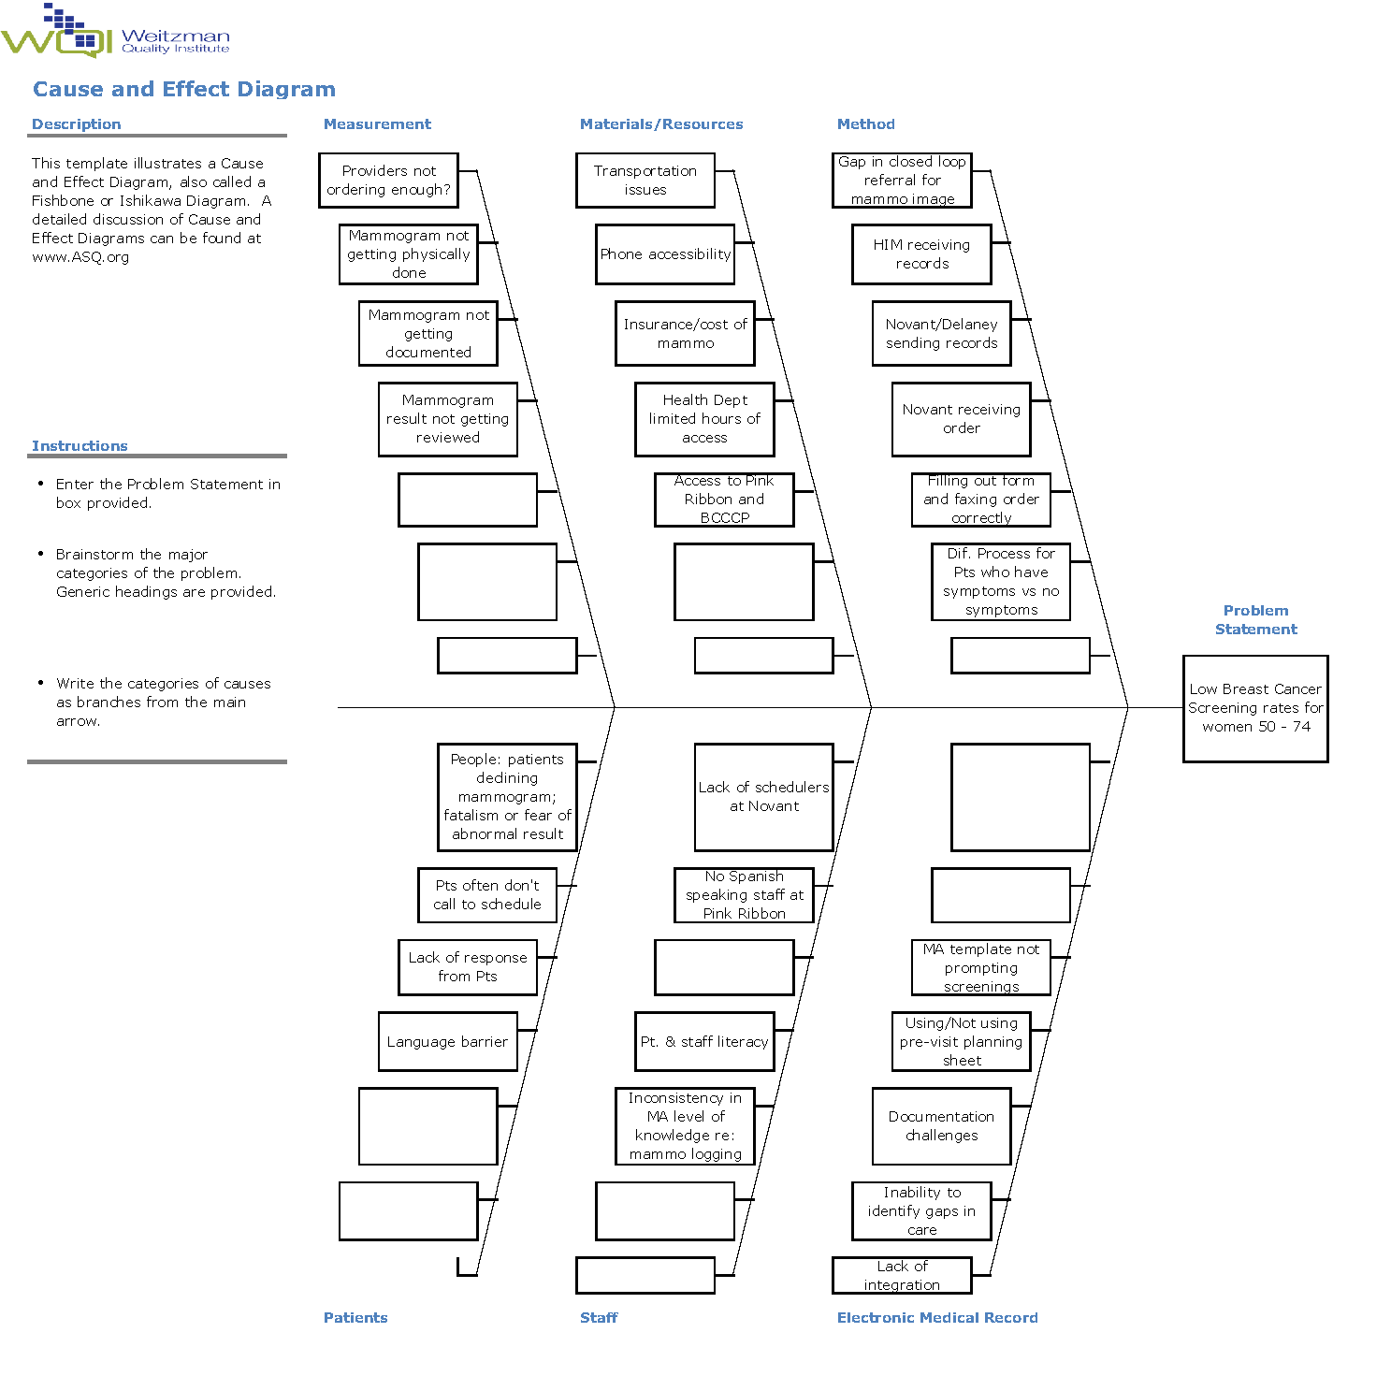
Fishbone Diagram Example

Deliverable – Complete your Fishbone Diagram
Download the template under “Additional Information” here

Step 5: Specific Aims and Measures
Overview
The Specific Aim is narrow, uses measurable targeted goals (numbers, percentages, rates), and is the basis for PDSAs. One Global Aim can have several Specific Aims, and one Specific Aim can have many PDSAs.
A good specific aim states: What you will accomplish and how you will know it when you do. Or don’t.
- A good aim is based on baseline data.
- A good aim has measures that are clearly defined:
  - What is being measured?
  - How it will be measured (numbers, percentages, rates)?
  - When it will be measured?
- A good aim is achievable. That is, you can get the data and change the process that results in the data.
- A good aim is the foundation for PDSA(s).

KEY POINT: A measurable specific aim is the foundation for PDSA(s).

Example of weak specific aim: We aim to increase screening rate for breast cancer in women patients by 15% from January to March.
Better: We aim to increase screening rate for breast cancer in female patients ages 50-74 from 22% as of as of December 31, 2024 to 37% by March 31, 2025.
Percent versus percentage points in specific aims: People often use percent and percentage point increases and decreases interchangeably but they are different (Table 3). You will find that using percentage points is cleaner. In Table 3 below, if the baseline is 22%, then a 15% increase is 25.3%. But an increase in 15 percentage points is an increase from 22% to 37%. That is a big difference in the numbers of patients you will need to screen to reach your target! Examples for increasing (Table 4) and decreasing (Table 5) rates are below using percent v percentages are below. For more detailed examples, see Tables 6 and 7.
Table 3. Percent v Percentage Points
Percent | Baseline screening rate: 22%  We aim to increase screening rate for breast cancer in eligible female patients by 15% from December 31, 2024 to March 31, 2025. (Note: A 15% increase from a baseline of 22% is 25.3%, but that is not clear in this aim).
Percentage Points | Baseline screening rate: 22%  We aim to increase screening rate for breast cancer in eligible female patients by 15 percentage points from 22% from December 31, 2024 to 37% by March 31, 2025.

KEY POINT: Percentage points are cleaner and easier to work with.
Table 4. Increase screening rate: percent v percentage points
Month | # eligible patients: | # screened eligible patients: Subset A | 15% Percent increase | 15 Percentage points increase
December 31, 2024 Baseline | 150 | 33 | Baseline 22% | Baseline 22%
June 30, 2025 Target | 150† | Target ??? | 22% * 1.15 =Target 25.3% | 22% + 15 points = Target 37%
How many more patients need to be screened by March 31, 2025? |  |  | Target 38 patients which is 5 more patients | Target 56 patients, which is 23 more patients
†Challenge: The baseline of 150 patients is as of December 31, the end of the fourth quarter. But you don’t know yet how many eligible patients will keep their appointments in the first quarter of 2025. What will you use for your denominator? You can use 150 or you can estimate the denominator based on previous quarters.

KEY POINT: Estimate the denominator for your targets based on
previous periods of data collection.

Table 5. Decrease no-show rate: percent v percentage points
Month | # patients with scheduled appointments: A+B | # no-show patients: A | 15% Percent decrease | 15 Percentage points decrease
December 31, 2024 Baseline | 150 | 33 | Baseline 22% | Baseline 22%
March 31, 2025 Target | 150† | Target ??? | 22% * 0.85 =Target 18.7% | 22% - 15 points = Target 7%
How many fewer no-shows in March 31, 2025 |  |  | Target 28 patients which is 5 fewer no-shows | Target 11 patients, which is 22 fewer no-shows

Table 6. Doing the math: increase percent v percentage points (screening example)
Calculating a 15% increase | Calculating 15 percentage points increase
- What is the target percent?  22% (baseline) * 1.15 increase = 25.3% (target percent)  - How many screened patients represent the target?  X patients/150 patients = 25.3%  0.253*150 = 37.95 (38) target patients to be screened [Check in reverse:  X = 38 patients (38/150=.253 or 25.3%] target screened]  - How many more patients need to be screened?  38 patients (target screened) - 33 patients (baseline screened) = need 5 more patients screened to increase percent screened by 15%. | - What is the target percent?  22% (baseline) + 15 points = 37%  - How many screened patients represent the target?  .37*150 = 55.5 [56] patients target patients to be screened  - How many more patients need to be screened?  3.56 (target) – 33 (baseline) = 23 more patients screened to increase percent screened by 15 percentage points.
Table 7. Doing the math: decrease percent v percentage points: no-show examples
Calculating a 15% decrease | Calculating 15 percentage points decrease
- What is the target percent?  - 22% x .85 = 18.7% (target)  - How many no-shows represent the target?  - X/150 = 18.7%  - 0.187 * 150 = 28 patients [Check in reverse: X= 28 so (28/150) = 18.7%]  - How many fewer no-shows is that?  - 33 (baseline) – 28 (target) = 5 fewer No Shows | - What is the target percent?  22%-15 points = 7%  - How many no-shows represent the target?  0.07*150 = 10.5 [11] patients  - How many fewer no-shows is that?  33 (baseline) -11 (target) = 22 fewer no shows

Helpful Tips
- Define the population and subsets precisely.
- Use baseline data and target data as percentage points: “from 15% to 25%”
- Be realistic, e.g., “from 15% to 50%” may be unrealistic.
- Make the time frame doable: long enough to measure change, but not so long that you can’t modify the PDSA if it is not working.

Specific Aim Example
We aim to: An improvement should be measurable—either you want to increase a rate or percentage (breast cancer screening) or you want to decrease a rate or percentage (no-shows).
- Example: We aim to increase the percentage of documented breast cancer screenings…[rest of definition]
By: How much of an improvement are you aiming for? A percentage increase by itself is weak and not measurable. It works best if you have a baseline and target than just a percentage increase (more on that later).
- Example: from 22% to 25.3%
By: When will you measure your outcome? You need enough time to do some PDSAs and give them a chance to work. Have a beginning (baseline data) and ending date (target). Targets are usually measured in weeks, months, or quarters.
- Example: from December 31, 2024 to March 31, 2025

Deliverable – Specific Aim Template
We aim to: improve increase decrease
The: quality of number/amount of percentage of [process/measure]
By: [percentage] AND/OR From: [baseline number/percent] To: [target number/percent]
By/Between: [date]

Step 6: Solution Storming and Change Ideas
Overview
There are many ways to find solutions to problems, to identify strategies to achieve aims. Begin with what you already know about your practice based on your assessment data, process mapping, fishbone diagram, talks with stakeholder, and so on. For example, there are probably several steps in the breast cancer screening process that you can improve, such as:
- Who identifies the patients who are due for a mammogram, and how do they do that?
- Can you create standing orders for mammograms? Can you allow Medical Assistants to place the order for the mammogram?
- Is the mammogram off-site? Who makes the referral for an appointment for the mammogram?
- Do you have a system for follow-up to see if the patient made and/or attended the appointment for their mammogram?
- How do you receive the report and get the results recorded into the electronic health record?
- Who communicates the results to the patient?

Additional items to consider include:
- Workflow and Time: Who does what when how and why? How can we be proactive instead of reactive?
- Eliminate Redundancies: Why are some tasks done twice and some are not done at all?
- Data: What data do we need and when do we need it? How do we get it?
- Responsibilities and Roles: Why are several people doing the same task? Why are they all doing it differently?

What can YOU change? Brainstorm Activity – Get your team together and identify what steps you want to focus on. Spend a few minutes writing down possible solutions and post them for review. These will help you with ideas for PDSAs.

Step 7: PDSA
Before completing Step 7, review Appendix B for the detailed process for breast cancer screening up until this point.
Overview
Plan-Do-Study-Act (PDSA) Cycle is an approach to testing a change and learning from the experience. These are intended to be small tests of change. In many cases, multiple PDSAs are needed to achieve your specific aim. The PDSA cycle invloves:
- Plan: This phase comes from the Specific Aim Statement
  - WHAT are we striving to accomplish?
  - WHAT will we do?
  - WHEN will this occur (what is the timeline)?
  - HOW MUCH? What is the specific, numeric improvement we wish to achieve?
  - FOR WHOM? Who is the target population?
- Do: This phase is as it sounds – just do it! This marks the implementation of the improvement, and during this phase it’s important to not only collect and document data around the improvement, but also to document the other things listed. QI efforts generate many learnings and it’s important to capture these.
  - Implement the improvement
  - Collect and document the data
  - Document the problems, unexpected observations, lessons learned, and knowledge gained
- Study: This phase involves analyzing the effect of the intervention.
  - Analyze the results – Was an improvement achieved? Compare the new data to the baseline data to determine whether an improvement was achieved, and whether the measures in the aim statement were met.
  - Document lessons learned, knowledge gained, and any surprising results that emerged
- Act: This phase marks the culmination of the planning, testing, and analysis regarding whether the desired improvement was achieved as articulated in the aim statement, and the purpose is to act upon what has been learned.
  - If the improvement wasn’t quite achieved, but we feel it was close, we will adapt our “test,” and either extend the testing period or revise something and repeat the testing cycle.
  - If the improvement was achieved, it’s time to adopt it as standard practice. Once we have adopted and standardized the improvement, we still need to monitor the situation and make sure the improvement holds.
See Appendix C for data collection plan.

PDSA Example
Aim: We aim to increase screening rate for breast cancer in female patients ages 50-74 from 22% as of as of December 31, 2024 to 37% by March 31, 2025.
Describe your first (or next) test of change: | Person Responsible | When to be Done (Date and Timeframe) | Where to be Done  (Site Location, Where are the site, Pod, etc.)
Audit patients who have no recorded mammogram or no recorded mammogram in the past 28 months to determine current participation rate amongst eligible patients | John and Jane | 4/1/2025 – 5/1/2025 | Site A, Pod X
Plan:
List the tasks needed to set up  this test of change | Person Responsible | When to be Done (Date and Timeframe) | Where to be Done  (Site Location, Where are the site, Pod, etc.)
- Designated staff member/s to host a practice meeting and plan Cycle 1.  - Designated staff member/s to audit patient records to determine the proportion of eligible patients who have no recorded mammogram or no recorded mammogram in the past 28 months. | John and Jane | 4/1/2025 – 5/1/2025 | Site A, Pod X

Predict what will happen when the test is carried out | Measures to determine if prediction succeeds | Person (s) Responsible for Collection of Data
Increase in eligible female patients getting screened for breast cancer | Breast cancer screening measure | Sally

Do: Designated staff members audit patient records to determine the proportion of patients aged who have no recorded mammogram or no recorded mammogram in the past 28 months.
Study: Designated staff members meet to review and discuss findings (proportion of patients with no mammogram recorded or no mammogram recorded in the past 28 months).
Act: Provide reminders to patients via letters, SMS, and/or audio messages to help encourage participation in breast cancer screening.

Deliverable – PDSA Template
Date:
Team Members:
Pre-Planning Tools To Consider (highlight): | Stakeholder Analysis, Communication Plan, Communication Matrix, Influencing Strategy, Facilitated Site/Dept. Meeting

Aim: your overall goal that you wish to achieve
Every goal will require multiple smaller tests of change
Describe your first (or next) test of change: | Person Responsible | When to be Done (Date and Timeframe) | Where to be Done  (Site Location, Where are the site, Pod, etc.)

Plan:
List the tasks needed to set up  this test of change | Person Responsible | When to be Done (Date and Timeframe) | Where to be Done  (Site Location, Where are the site, Pod, etc.)

Predict what will happen when the test is carried out | Measures to determine if prediction succeeds | Person (s) Responsible for Collection of Data

Do: describe what actually happened when you ran the test
Study: describe the measured results and how they compared to the predictions
Act: describe what modifications to the plan will be made for the next cycle from what you learned

Step 8: SDSA – Test the “New Process” with Another Teamlet
Overview
Standardize-Do-Study-Act (SDSA) Cycle is an approach to standardizing a process and learning from the experience. Prior to full organizational standardization, there are several steps to ensure the process is adaptable to teams outside of the original improvement team. Once your team has successfully tested and refined the PDSA, it is time to share or spread this to another teamlet or pod.
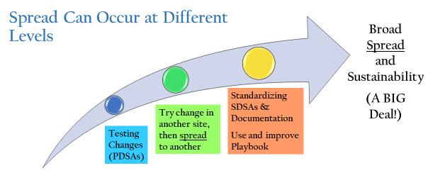
Use the below SDSA template to test the spread. We recommend using the same rigor of testing, monitoring, and measurement as done during a PDSA. It is important to document what you learn and adapt as needed to move towards organizational standardization.
Deliverable – SDSA Template
Tasks to be completed to test standardization and monitor process to run test of change | Who | When | Tools or Training needed | Measures

Do: What are we learning as we do the standardization? Any problems encountered? Any surprises? Any new insights to lead to another PDSA cycle?
Study: As we study the standardization, what have we learned? What do the measures show? Are there identified needs for change or new information or a tested best practice to adopt?
Act: As we act to hold the gains or modify the standardization efforts, what needs to be done? Will we modify the standardization? What is the change idea? Who will oversee the new PDSA? Design a new PDSA cycle. Make a plan for the next cycle of change if needed. Use your communication plan tool.

Overview – Playbooks
A playbook is a tool that can be developed and used to train others to the “new” process. Playbooks are a detailed document that describes the standard process and often includes pictures and/or screenshots that show people exactly what and how to complete steps.

Deliverable – Complete your Playbook
Download the template under “Additional Information” here

Step 9: Spread/Standardize the “New Process”, Measure, and Monitor
Overview
Of the newly standardized process following the replication of that change with other teams or teamlets is a critical time of quality improvement work. This phase requires careful planning and detailed communication with leaders within your organization. This communication will lead to the planning of trainings and education for all involved staff. The playbook is a key tool during this time.
Spread is the process of taking a successful implementation process from a pilot, and replicating that change or package of changes (playbook) in other teams within a practice or in other practices. During implementation, teams learn valuable lessons necessary for successful spread, including key resource issues, best sequence of tasks, and how to help team members adopt and adapt a change. Spread efforts benefit from the use of the SDSA cycle. Teams adopting the change have the skills to test the standard and work toward achieving the results of other teams.
You will know this process is successful when it becomes normalized:
- A process recognizable by all in the workplace as “the way we do things” here.
- Five staff members can regularly articulate the process steps when asked individually to describe the process.
- A “miss” (defect) in the process flow can be immediately identified so that it can corrected.
  - There is a process in place to identify a failed step in process
  - There is a communication plan to support correcting a process defect to all areas
- Measures clearly indicate that the process is working.

Helpful Tips for Communicating Spread
- Does leadership have all of the information they need to confidently speak with staff about the standardization?
- Have you gotten the approval of any committee or group internally that is required for standardization?
- Do you have a strategy to train the necessary staff on the standardization before it is implemented?
- Do you have (at the very least) the framework for a playbook that agency staff can use a reference?
- Have you developed a plan for evaluation with timelines and individuals responsible for measurement?
Once you’ve adopted – you sustain by:
- Monitor – reports, dashboards, quarterly meetings
- Maintain – who is the owner, process for looking into measures when they fall below?
- Check-In – conversations, connections, accountability, transparency, trust
- Develop/update playbook – a recipe to perform the new process, training tool, update playbooks when new systems or processes are put in place

Appendix A: Data Displays
Overview
A picture is worth a thousand words. A good data display tells a good story and is more powerful than a paragraph. But achieving a good data display is not always easy. Here are some things to consider:
- What type of data do you have? This was one of our first questions. The type of statistical analyses that you do, and thus the type of data displays that you use are determined by the type of data you have.
- Give your data display a lengthy title so that uninformed persons know what they are looking at.
  - Vague: Percent of patients screened
  - Better: Percent of eligible women ages 50-74 who had a mammogram in the first quarter of 2025.
- Label your data display/legend clearly. Numbers? Percentages? Time period?
- Beware of using both numbers and percentages in a chart.
- Interpretation of a graphic display requires context. Do not be quick to pass judgment without understanding the context for the choice of data collected, how it was collected, and how differences between data over time or between locations can be attributed to multiple factors.

KEY POINT: Interpretation of a graphic display requires context.

Types of Data Displays
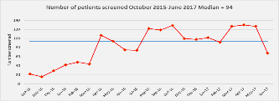
Run chart: A run chart displays data (Y axis) over a period of time (X axis). The time periods are uniform and sequential, that is month to month, or quarter to quarter. The Y axis label matches the title. In the chart below, it is the number of patients. The Y axis can be percentages as well. In the chart below, the red line is the number of patients screened, each dot represents the number screened in that month, and the blue line is the median (excel will do that for you). That is, the data is ratio data (has a natural zero). Run charts use a median, not a mean. A run chart is just a quick glance at data. Do not assume in the graph below that there is anything significant about Oct 2016 or June 2017. To determine any significant data points, you need a control chart, which requires special templates to develop and training to interpret.
When time is your X axis, you can use either a bar chart or run chart for just a few data points. But if you have 6 or more data points over time, use the run chart format.
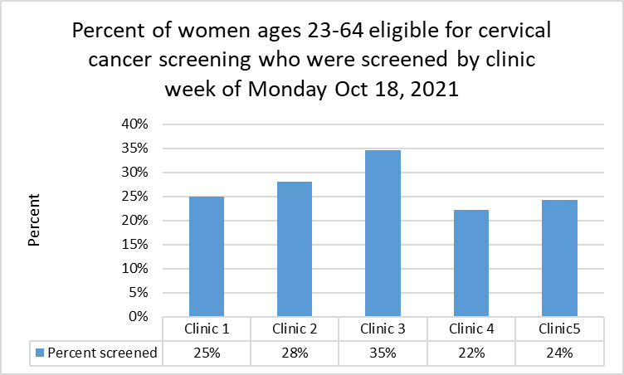
Bar chart (simple): The bar chart works best when the X axis is nominal data, e.g., clinic, provider, etc. It can represent raw numbers or percents. However, percent can be deceiving without knowing the denominators. The bar chart works best when the X axis is nominal data, e.g., clinic, provider, etc. Clinic 1 could also be Week 1 of a five week trial. But if you have 6 or more data points over time, use the run chart format instead. Note that the Y axis is from 0% to 40% only to make clearer comparisons.

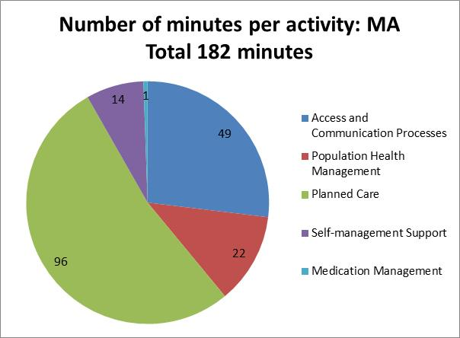
Pie chart: A pie chart displays data as parts of a whole, and usually use color fields to distinguish between “slices” of the pie. Compare two pie charts using the same data collected to identify how a medical assistant uses his/her time. The title tells the story and gives a reference for the “whole” of the pie: 182 minutes in total (which would become the denominator if you wanted to talk about percent). Thus the slices are in minutes as well. The legend lists five activities and there are five slices.

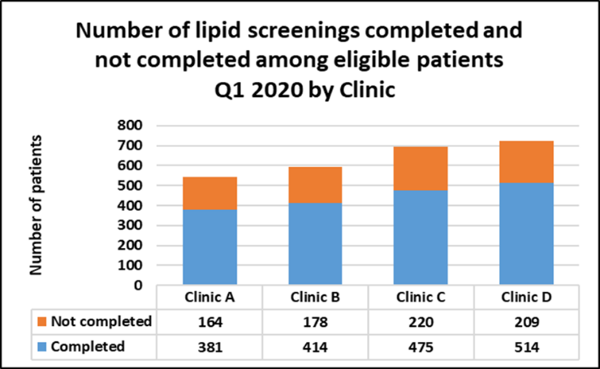
Bar graph (stacked): Like a pie chart, a stacked bar graph gives you the whole and its parts. The X axis can be time (Q1, Q2), locations (Clinic A, Clinic B), names (Provider A, Provider B), etc. The Y axis and the data in the legend along the X axis in the examples below both display numbers. Note the titles are highly descriptive. Don’t mix numbers and percentages, that is, display one or the other. Again, percent can be deceiving without knowing the denominators. In the examples, you can describe the data in more detail in a brief paragraph.
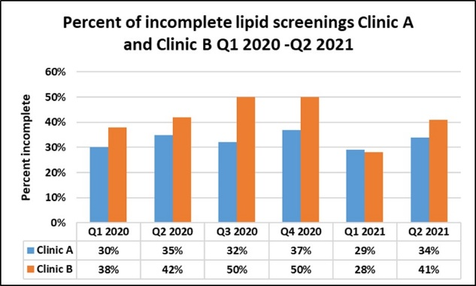
Side by side bar chart: Side by side bar charts are a good way to compare Pre and Post scores, or to compare two clinics side by side within the same time frames. Note the titles are highly descriptive.
This is a side by side bar chart comparing incomplete screenings rates between two clinics over time. Beware of interpretation without context about size of population, staffing, etc. Percent can be deceiving without knowing the denominators.

Appendix B: Detailing the Whole Process – Breast Cancer Screening
Global Aim Statement: We aim to improve the process for breast cancer screening in Dr. Smith’s panel at the Main St. Clinic. The process begins with identifying patients who are eligible for screening. The process ends with documenting in the patient’s health record that screening has occurred. By working on the process, we expect to improve the UDS measure for breast cancer screening rate. It’s important to work on this now because our current rate for breast cancer screening is in the 3rd quartile so we can’t take advantage of value-based reimbursements. Our rate has declined, but we have a lot of new staff and so have an opportunity to get a standardized workflow in place. We need to be better about making sure that our patients are being screened as the incidence of breast cancer in our population is higher than average. We’re pretty good about ordering the mammograms, but we don’t do mammograms at our clinic so we need to get better at having them documented in our records.
Problem Statement: We aim to improve the process for screening for breast cancer because our UDS measure is currently in the 3rd percentile. After looking at the data and talking to stakeholders, there seem to be two main issues: (1) the mammogram is not ordered at the time of the patient’s visit, and (2) the test results are not documented in the chart. We don’t know if #2 is because the patient did not follow through with an appointment or because the results were not sent to us by the external mammography center.
Specific Aim Statement: We aim to increase the percentage of documented breast cancer screenings from 22% as of December 31, 2024 to 25.3% by the end of March 2025 in women ages 50-74 who were eligible for a mammogram to screen for breast cancer in the 27 months prior to the end of the measurement period.
Possible steps in the screening process to address using PDSAs based on data and solution storming: who, what, when, where, how
- Identifying the patients who are due for a mammogram: How does this happen in the EHR now? Who does that? What can we try?
- Ordering the mammogram: Can the medical assistant place the order for the provider to review? What can we try?
- Making a referral for an appointment for the mammogram at the mammography center. Which center do we use? Or that is closest to the patient? Does the medical assistant or someone at the front desk send the referral? What can we try?
- Following up to see if patient made/attended the appointment for mammogram at the mammography center. Who can check on the referral status? Do we need a referral coordinator? Why don’t patients make an appointment? How do we ask them? Do we need more education? What can we try?
- Getting the report back from the mammography center. Where does it to? To Medical Records? How does it get into the chart? Who checks? What can we try?
Can you see how each step in the improvement ramp leads to the next? As we have said, you may go up one step only to go back two as you gather more information.

Appendix C: Data Collection Plan
Overview – How will you collect your data?
A PDSA states how you will make an improvement, that is, the strategies you will try to increase screening rates or decrease no-shows rates. Tracking the data will tell you if you are being successful or not. Identifying what does not work is just as important as identifying what does work. A data collection plan can help you to organize your work. A simple table or excel worksheet is fine. It should include:
- Name of measure
- Definition of measure: Use standardized definitions when they exist for Numerators and Denominators
- What date range are you interested in?
- Where does the data come from? EMR? Tick and tally sheets?
- How is the data collected, by whom?

Table 8. Data collection table: Example using UDS definition
We aim to increase screening rate for breast cancer in eligible female patients* ages 50-74 from 22% as of December 31, 2024 to 37% by March 31, 2025.
Name of measure | Definition:  Numerator | Definition:  Denominator | Dates of interest | How to get the data
Breast cancer screening | # female patients ages 50-74 who were eligible for a mammogram to screen for breast cancer in the 27 months prior to the end of the measurement period and who have the results of the mammogram documented in their chart | Total # number female patients ages 50-74 who were eligible for a mammogram to screen for breast cancer in the 27 months prior to the end of the measurement period | January, February, March 2025 (First quarter) | Colonel Mustard will get the data from the electronic record as it is available for each month and give it to Ms. Peacock who is leading this initiative. She will review it with the team.
*Assigned female at birth

Worksheet: Data Collection Plan for a PDSA
As a PDSA is a short test of change to determine the feasibility of a proposed new process, the time period may be one or two weeks, or even a few days, and the data collection might be done by hand.

Helpful Tips
- Be very clear about the definition of your measure.
- Be very clear about who is going to do what and when.
- This is the data that you will Study in your PDSA. How did it work?

Table 9. Data collection table: Example using PDSA measure
PDSA: Increase the number of orders placed for mammograms in eligible women patients.
Name of measure | Definition:  Numerator | Definition:  Denominator | Dates of interest | Getting the data: who, when, how
# mammogram orders placed | # female patients ages 50-74 who were eligible for a mammogram to screen for breast cancer who had an order placed in their chart during their visit | Total # female patients ages 50-74 who were eligible for a mammogram to screen for breast cancer at the time of their visit | Tuesday January 2 through Friday January 12 | Susie Q, MA and Dolly Madison, Provider will follow a new workflow with the assistance of IT, but will track it by hand (tick and tally sheet) for two weeks

