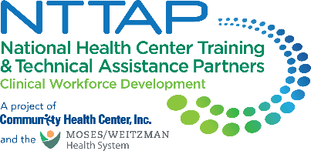
NTTAP Health Professions Student Training Learning Collaborative
Showcase Content Collection Tool
The NTTAP team wants to help each health center tell the story of your involvement in the Health Professions Student Training Learning Collaborative through a showcase. This showcase process will allow each health center to compile the work you have done in this learning collaborative in a simple snapshot for you to share with other team members, leadership, and partners to help you continue to implement and improve your health center’s health professions student training program.
Showcase Purpose
- Tell the story of your health center’s work during this learning collaborative in a clean, crisp, visual format
- Generate reflection among you and the other team members about your involvement in this learning collaborative
- Share your work in future meetings with other health center staff including leadership and external stakeholders such as the health center board, community partners, and funders

Process
- Complete the “Response” column in the table below following the prompts in the “Showcase Section” column.
- Send your completed template (one per health center) to Meaghan Angers at angersm@mwhs1.com by Friday June 6th.
- The NTTAP Team will design the showcase in Adobe Publisher using the content you provided in the template below.
- The NTTAP Team will send your draft showcase via PDF by Monday June 16th so your organization can provide any edits and/or feedback.
- Be prepared to share the showcase in the last learning session on Friday June 20th, 2025 at 2pm ET / 11am PT.

Showcase Content Guidelines
- Complete all the required sections (*) and complete as many other sections as possible
- Use bullets and begin with action verbs like “developed” and “established.”
- View the showcases at the end of this document for examples of how your information will be shaped into a showcase.

Showcase Content Collection Tool

Showcase Template Due: Friday June 6th
Please email to Meaghan Angers at angersm@mwhs1.com; if you need an extension, please let me know.
* = required sections

Showcase Section | Response
*Health Center Name and logo
- Type your health center name in the response box.
- Send image to Meaghan Angers at angersm@mwhs1.com.
*Health Center Description
- Provide a brief description of your health center.
*Innovations
- List about 3-5 changes that demonstrate your health center’s movement toward implementing a Health Professions Student Training Program.
* ‘Aha’ Moment(s)
- “Lightbulb” moment during this learning collaborative opportunity.
*Recommendation(s) to others
- Provide about 3 recommendations for others starting to implement a Health Professions Student Training Program or in the learning collaborative.
Aim Statement / Mission and Vision Statement
- Add your most up-to-date aim statement, mission statement, and/or vision statement for your Health Professions Student Training Program.
Program Drivers
- Add your most up-to-date program drivers for your Health Professions Student Training Program.

Measures/Impact
- Looking at your data or Baseline Assessment, identify the most significant data point that highlights the importance of your work. You may use the results from the ORIC or RTAT self-assessment, which are available via your Google Drive folder.
Key Partners
Stakeholders related to the goals of this project:
- Internal: within the health center- (leadership, patient advisory groups)
- External: outside of the health center (community organizations; schools; universities)
- Do not include names – just titles and/or organizations
Voice of the Team
- Provide a brief statement from one of the team members about the impact of your project work
- List name of team member and job title
Voice of Leadership
- Provide a brief statement from a health center leader on the impact of your project work on the health center organization
- List name of leader and job title
- Could use a quote from the application/letter of intent submitted for this learning community
Process Map or other Visuals
- Visuals such as photos, graphs, or updated workflows/process maps
- This can include any of your work incorporated in your playbook.
- Send image to Meaghan Angers at angersm@mwhs1.com.
Other
Include any comments, thoughts, or deliverables that you completed during the Collaborative that was a success to implement your Health Professions Student Training Program.
* Required

Example Showcase
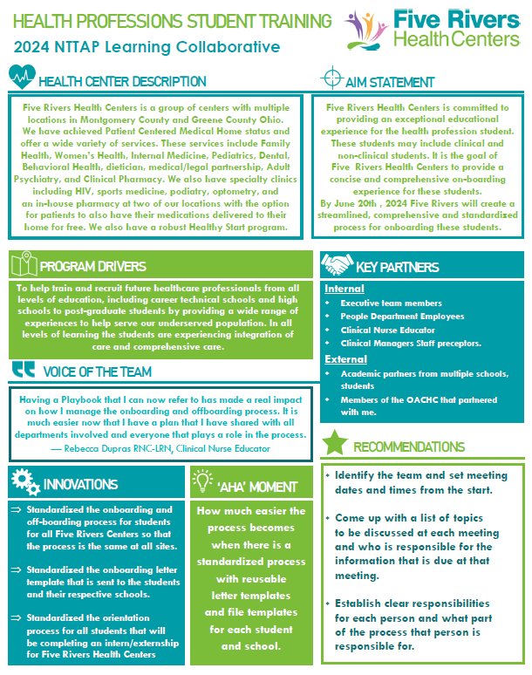
Example Showcase

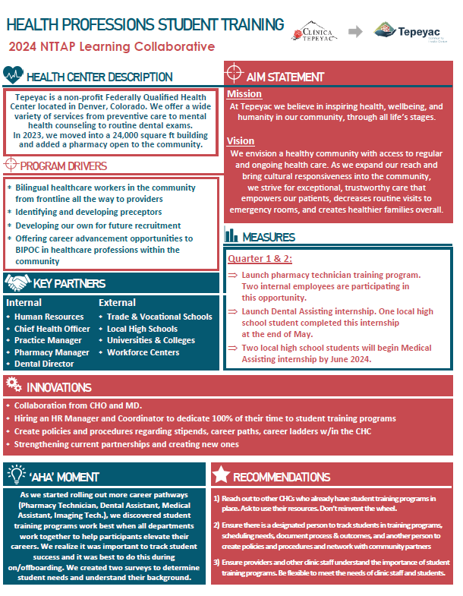
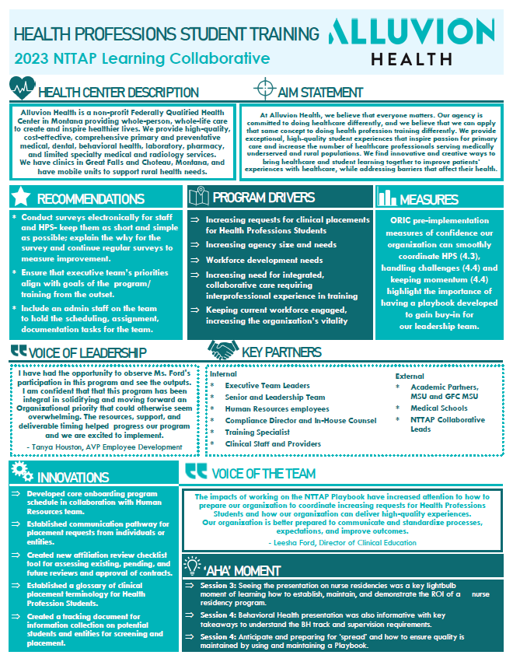
Example Showcase
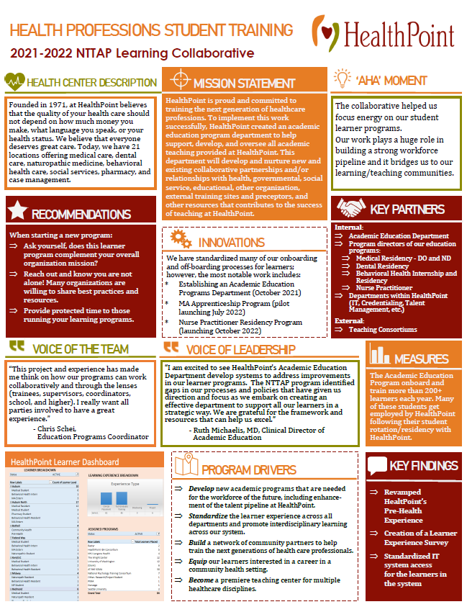
Example Showcase
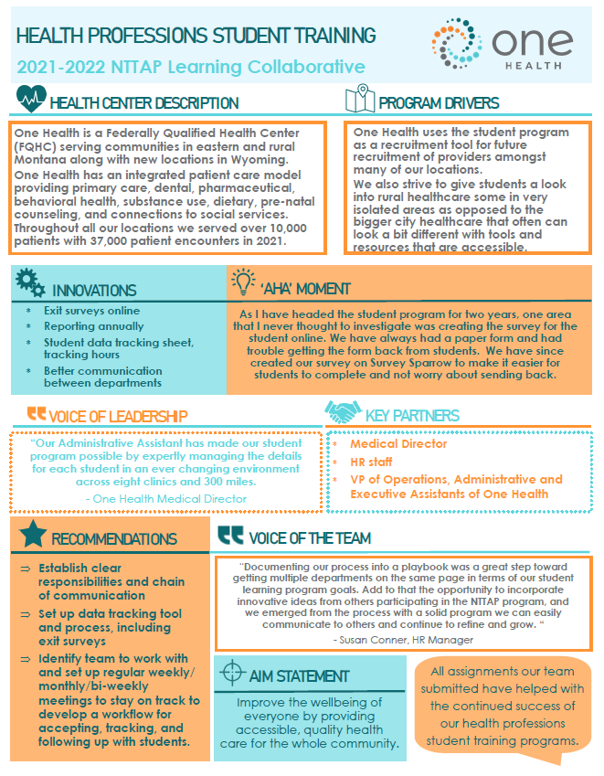
Example Showcase

