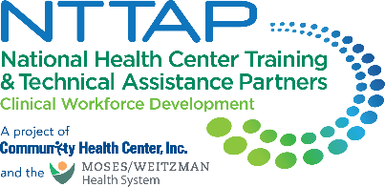
NTTAP Comprehensive and Team-Based Care Learning Collaborative
Showcase Content Collection Tool
The NTTAP team wants to help each health center tell the story of your involvement in the NTTAP Comprehensive and Team-Based Care Learning Collaborative through a showcase. This showcase process will allow each health center to compile the work you have done in this learning collaborative in a simple snapshot for you to share with other team members, leadership, and partners to help you continue to implement team-based care at your health center.
Showcase Purpose
- Tell the story of your health center’s work during this learning collaborative in a clean, crisp, visual format
- Generate reflection among you and the other team members about your involvement in this learning collaborative
- Share your work in future meetings with other health center staff including leadership and external stakeholders, such as the health center board, community partners, and funders

Process
- Complete the “Response” column in the table below following the prompts in the “Showcase Section” column.
- Send your completed template to Meaghan Angers at angersm@mwhs1.com by Wednesday May 21st, 2025. If you need an extension, please let Meaghan know.
- The NTTAP Team will design the showcase in Adobe Publisher using the content you provided in the template below.
- The NTTAP Team will send your drafted showcase via PDF by Friday May 30th, 2025 so your organization can provide any edits and/or feedback.
- Be prepared to share the showcase in the last learning session on Wednesday June 11th, 2025 at 1pm ET / 10am PT

Showcase Content Guidelines
- Complete all the required sections (*) and complete as many other sections as possible
- Use bullets and begin with action verbs like “developed” and “established.”
- View the showcases at the end of this document for examples of how your information will be shaped into a showcase.

Showcase Content Collection Tool

Showcase Template Due: Wednesday May 21st, 2025
Please email the completed showcase template to Meaghan Angers at angersm@mwhs1.com. If you need an extension, please let Meaghan know.
* Required

Showcase Section | Response
*Health Center Name and logo
- Type your health center name in the response box
- Send image to Meaghan Angers at angersm@mwhs1.com – please do not embed images in the Word document
*Health Center Description
- Provide a brief description of your health center
*Innovations
- List about 3-5 changes that demonstrate your health center’s movement toward implementing team-based care in your organization.
* ‘Aha’ Moment(s)
- “Lightbulb” moment(s) during this learning collaborative opportunity
*Recommendation(s) to others
- Provide about 3 recommendations for others starting to implement team-based care in their organization or in the learning collaborative
Global Aim Statement
- Add your most up-to-date global aim statement
Process Map, Fishbone Diagrams, & Graphs
- Visuals such as process maps, fishbone diagrams, photos, graphs, etc.
- Send image and/or document to Meaghan Angers at angersm@mwhs1.com – please do not embed images in the Word document
Specific Aim Statement
- Add your most up-to-date specific aim statement

PDSA Reflections
- Share any key findings from conducting your PDSA
Measures/Impact
- Looking at your data from your quality improvement project identify the most significant data point that highlights the importance of your work.
- This can also include data from your baseline self-assessments, including the Primary Care Team Guide, Coach Skills, and Team Skills. These are available in your Google Drive folder.
Key Partners
Stakeholders related to the goals of this project:
- Internal: within the health center- (leadership, patient advisory groups)
- External: outside of the health center (community organizations; schools; universities)
- You do not need to include names – just titles and/or organizations
Voice of the Team
- Provide a brief statement from one of the team members about the impact of your project work in the learning collaborative
- Please provide the name and title of the team member
Voice of Leadership
- Provide a brief statement from a health center leader on the impact of your project work in the learning collaborative on your organization
- Please provide the name and title of the team member
- You could also use a quote from the learning collaborative application
Other
- Include any comments, thoughts, or deliverables that you completed during the learning collaborative that was a success to implement team-based care in your organization, or any thoughts/key findings from working on your quality improvement project.
* Required
Example Showcase
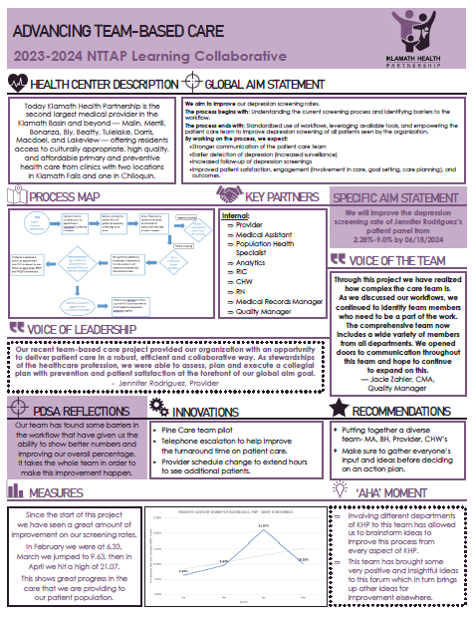
Example Showcase
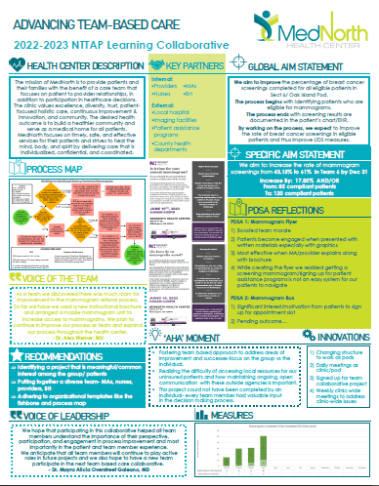

Example Showcase

