Aim Statement & Balanced Measures Template
Background
The Aim Statement describes how your team will achieve the vision outlined in your Purpose Statement and what you hope to accomplish through participation in this learning collaborative.
Metrics will be selected using a Balanced Measures approach, ensuring a well-rounded view of success. This includes financial data, process and outcome measures, and satisfaction data, all of which are critical to overall project success.
Approach: Developing the Aim Statement
Meet with your team to review and reflect on your Purpose Statement.
Work collaboratively to complete the Aim Statement using the template provided in this worksheet.
Keep in mind that creating a strong Aim Statement can be a messy and iterative process, be sure to allow adequate time for thoughtful discussion.
Approach: Identifying Balanced Measures
Refer to the “...by doing so, we expect…” portion of your Aim Statement to help define what success looks like.
The Balanced Measures template includes four quadrants. Aim to identify one or two measures per quadrant. You may choose to collect data on only a few of these, but completing all four quadrants encourages broader thinking about how to measure ECTP success.
Note: These exercises may take more than one meeting. Don’t worry about getting it perfect, focus on the process, think expansively, and aim for a solid working draft that your team can revisit and refine over time.

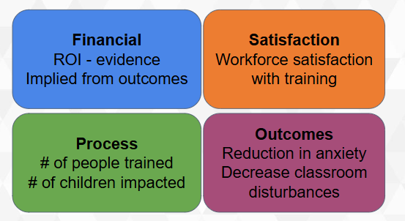

Aim Statement Template:

“We aim to (increase/decrease/achieve) ___________. We will do this by (providing/improving/addressing) ___________. By doing so, we expect (outcomes/benefits)____________. It’s important to address this now because_____________.”

Example Aim Statement:

We aim to increase educator confidence in managing disruptive behaviors in the classroom. By doing so, we expect improved confidence among educators and a decrease in the number of disruptive classroom events. It is important to address this now in order to create a healthy learning environment for students and educators.

