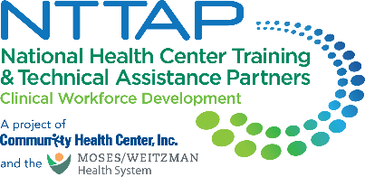
NTTAP Comprehensive and Team-Based Care Community of Practice (CoP)
Showcase Content Collection Tool
The NTTAP team wants to help each health center tell the story of your involvement in the NTTAP Comprehensive and Team-Based Care Community of Practice (CoP) through a showcase. This showcase process will allow each health center to compile the work you have done in this CoP in a simple snapshot for you to share with other team members, leadership, and partners to help you continue to implement team-based care at your health center.
Showcase Purpose
- Tell the story of your health center’s work during this CoP in a clean, crisp, visual format
- Generate reflection among you and the other team members about your involvement in this CoP
- Share your work in future meetings with other health center staff including leadership and external stakeholders, such as the health center board, community partners, and funders

Process
- Complete the “Response” column in the table below following the prompts in the “Showcase Section” column.
- Send your completed template to Meaghan Angers at angersm@mwhs1.com by Monday May 11th. If you need an extension, please let Meaghan know.
- The NTTAP Team will design the showcase in Adobe Publisher using the content you provided in the template below.
- The NTTAP Team will send your drafted showcase via PDF by Friday May 29th, 2026 so your organization can provide any edits and/or feedback.
- Be prepared to share the showcase in the last learning session on Wednesday June 3rd, 2026 at 1pm ET / 10am PT

Showcase Content Guidelines
- Complete all the required sections (*) and complete as many other sections as possible
- Use bullets and begin with action verbs like “developed” and “established.”
- View the showcases at the end of this document for examples of how your information will be shaped into a showcase.

Showcase Content Collection Tool

Showcase Template Due: Monday May 11th, 2026
Please email the completed showcase template to Meaghan Angers at angersm@mwhs1.com. If you need an extension, please let Meaghan know.
* Required

Showcase Section | Response
*Health Center Name and logo
- Type your health center name in the response box
- Send image to Meaghan Angers at angersm@mwhs1.com – please do not embed images in the Word document
*Health Center Description
- Provide a brief description of your health center
*Innovations
- List about 3-5 changes that demonstrate your health center’s movement toward implementing team-based care in your organization.
* ‘Aha’ Moment(s)
- “Lightbulb” moment(s) during this learning collaborative opportunity
*Recommendation(s) to others
- Provide about 3 recommendations for others starting to implement team-based care in their organization or in the learning collaborative
Global Aim Statement
- Add your most up-to-date global aim statement
Process Map, Fishbone Diagrams, & Graphs
- Visuals such as process maps, fishbone diagrams, photos, graphs, etc.
- Send image and/or document to Meaghan Angers at angersm@mwhs1.com – please do not embed images in the Word document
Specific Aim Statement
- Add your most up-to-date specific aim statement

PDSA Reflections
- Share any key findings from conducting your PDSA
Measures/Impact
- Looking at your data from your quality improvement project identify the most significant data point that highlights the importance of your work.
- This can also include data from your baseline self-assessments, including the Primary Care Team Guide, Coach Skills, and Team Skills. These are available in your Google Drive folder.
Key Partners
Stakeholders related to the goals of this project:
- Internal: within the health center- (leadership, patient advisory groups)
- External: outside of the health center (community organizations; schools; universities)
- You do not need to include names – just titles and/or organizations
Voice of the Team
- Provide a brief statement from one of the team members about the impact of your project work in the learning collaborative
- Please provide the name and title of the team member
Voice of Leadership
- Provide a brief statement from a health center leader on the impact of your project work in the learning collaborative on your organization
- Please provide the name and title of the team member
- You could also use a quote from the learning collaborative application
Other
- Include any comments, thoughts, or deliverables that you completed during the learning collaborative that was a success to implement team-based care in your organization, or any thoughts/key findings from working on your quality improvement project.
* Required

Example Showcase
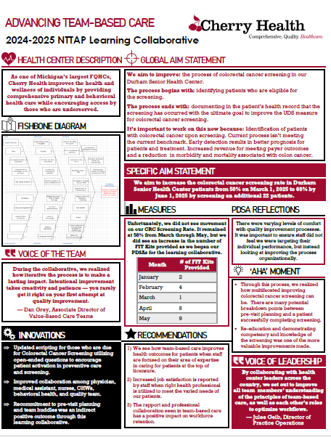
Example Showcase
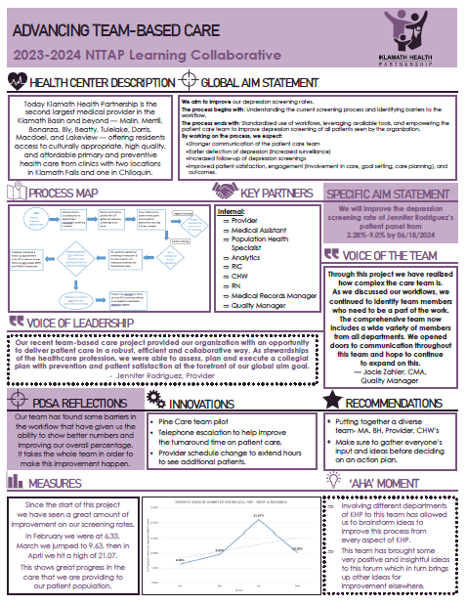
Example Showcase

